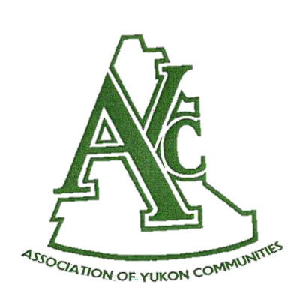
The Linda Rapp
Municipal Employee Award
Nomination Guidelines
Deadline: Apr. 5, 2024

This AYC award recognizes the contribution of an employee of a member community who has
demonstrated an exceptional level of professionalism, leadership, and innovation in their job.
The nominee(s) must be, or have been, an employee of a Yukon municipality.

Name of Municipal Council in Yukon:

Form Submission Date

Name of Nominee

Present title of Nominee

Dates of municipal service

Past titles during municipal service

Describe how they demonstrated an exceptional level of professionalism, leadership, and innovation in their job (approx. 200 words):

Particular achievements:

Particular activities undertaken:

Previous awards for municipal service:

