December 8th 2018
Report to the Council of the City of Pitt Meadows

To: Mayor Bill Dingwall and Councillors
From: George B Cuff & Associates Ltd.
Re: Governance Model for Agencies, Boards and Committees
Thank you for this opportunity to provide guidance and assistance to the City of Pitt Meadows relative to an assessment of the current and future state of its agencies, boards and committees (referred herein as the “ABCs”).
This has been a challenging engagement in that the number of issues related to an effective system of governance are numerous and the options for change almost equally so.
In the course of our Review, we met with and listened to a wide range of committee members and heard their observations as to what is working and what might need to change. Each expressed interest in seeing the report. We also interviewed the Mayor and Councillors to garner their assessment.
City Council is to be commended for this leadership initiative in supporting its volunteers and the general public through looking at how their input can be made more effective and at how Council can add more value to its processes of decision-making. We believe that the changes recommended will do just that and that the City will be well-served in terms of its advisory structure for the foreseeable future.
Our Report reflects the public input which the consultant has received to date.
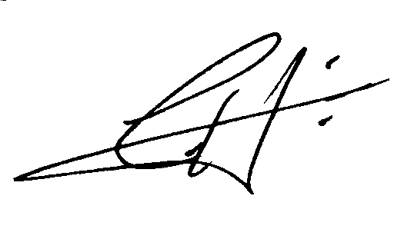
With best regards,

George B Cuff, FCMC
President
George B Cuff & Associates Ltd.

Table of Contents
1.0 Purpose 5
2.0 The Committees 6
3.0 Terms of Reference 6
4.0 Methodology 7
5.0 Current Status (Summary of Committee Background and Purpose) 8
5.1 The Committees 8
6.0 A Summary of Findings 15
7.0 Public Involvement 18
7.1 Public Engagement 19
7.2 Open Government 21
7.3 Related Policies 22
8.0 City Roles and Responsibilities 23
8.1 The Impact on Council 23
8.2 The Impact on Administration 24
8.3 Protocols 25
9.0 Guidance to Support Staff 26
10.0 Current Governance Model for Council 26
10.1 Regular Meetings of Council 27
10.2 Council in Committee (CIC) 27
10.3 Committee Categories 27
11.0 Relevant Communities 31
12.0 Governance Model Options 32
12.1 Description of Options 32
13.0 Key Alternatives for Pitt Meadows 41
13.1 The Legal Umbrella 41
13.2 Community-Created Committees 43
13.3 Council’s Flexibility 44
14.0 Objectives and Criteria 44
15.0 Governance Model Options 46
15.1 Option One: Current Governance Model 46
15.2 Option Two: Three Standing Committees plus PACS 48
15.3 Option Three: Strategic Priorities Committees 51
15.4 Option Four: Community Roundtables 53
15.5 Option Five: Recommended New Governance Model (Governance & Priorities Committee) 57
15.5.1 Community Roundtables 58
15.5.2 Councillor Initiatives 59
15.5.3 Strategic Priorities 59
16.0 The Recommended Model 60
16.1 Governance and Priorities Committee (GPC) 60
16.2 Terms of Reference 61
16.3 Councillor Initiatives 62
16.4 Public Advisory Committees 62
16.5 Technical Advisory Committees 63
16.6 Roundtables 64
16.7 Task Forces 64
17.0 Key Support Roles 64
17.1 Role and Impact of the Chief Administrative Officer 64
17.2 Role of Senior Management 65
17.3 Enhanced role of the Corporate Officer 66
17.4 Administrative Review of Agenda Issues 67
18.0 What Will Change? 67
19.0 Recommendations 69
Appendix A: External Committees 73
Appendix B: ABC Code of Conduct 76
Appendix C: ABC Operating Principles 80
Appendix D: ABC Checklist 83
Appendix E: Guidance to ABC Members (Current Structure) 85
Appendix F: Agenda Process 89
Appendix G: The ABCs of Other Comparable Communities 90
Appendix H Template Governance & Priorities Agenda 109

Section A: The Background

1.0 Purpose
The purpose of this Review was based on the City’s belief that its current structure and utilization of its ABCs (agencies, boards and committees) is important to its overall civic governance; that it may not be functioning as well as the City’s Council and administration believes that it should; and that an external perspective might help re-set that relationship.

Based on the correspondence which we received in early January 2018, the sentiment of the City seemed to be one of questioning how its system of ABCs might be restructured so as to align with Council, its strategies and its other options for engaging the community. There seemed to be two key objectives:

- one, that citizens will be encouraged to participate in Council’s decision-making by offering their perspectives/advice on issues of interest to them; and
- two, that Council will have access to opinions other than their own (and that of their administration) on key community issues.

Council by virtue of its election is presumed to represent and reflect the majority view of the community’s citizens. While it is expected to act on its best judgment, it does have access to a very experienced group of senior managers who come at the issues from an apolitical perspective and often with a wealth of background experience. This combination of political acumen and public sector expertise and analysis generally produces good decisions which would quite frequently be endorsed by the community as acceptable. Being able to add to that mix an additional layer of reasoned opinions from those most affected by outcomes will often be to the advantage of the Council.

This assessment (and Report) is addressed to the question: how best to accomplish balanced and effective decisions within a structure which is comprehensive yet expedient and mindful of the limited administrative resources of a relatively small city?

2.0 The Committees
We are advised that the committees under review are as follows:
- Active Transportation Advisory Committee
- Advisory Design Panel
- Agricultural Advisory Committee
- Community Events Liaison
- Green Team Committee
- Pitt Meadows Airport Advisory Committee
- Rail Community Advisory Panel
- Municipal Advisory Committee on Accessibility and Inclusiveness (MACAI)
We note that the list of committees expanded since we began this Review to include, at least for general purposes, those to which the Council appoints members. We have also incorporated the current standing committee i.e. Council in Committee (CIC) as that impacts the style and nature of reporting by other committees.

3.0 Terms of Reference
The consultant was asked to:
- Review the current Council committee system: the purpose of each advisory committee established by Council; its frequency of reporting; Council’s sense of “added value”; any impact on Council’s decision-making; currency of information to all members of Council; etc.
- Assess each committee bylaw, terms of reference or current “charter” and determine the appropriateness of each
- Seek the feedback of each committee as to their perception of value and how that might be positively changed
- Review and assess the alignment of the vision with the direction established by Council’s strategic priorities
- Provide an assessment of the current governance model in terms of how it impacts the decision-making of Council; review the impact of the current approach to policy development to Council’s governance
- Ensure that the perspectives of Council members have been considered in our analysis; review their role vis-à-vis committees and how useful that has been
- Assess the linkage to the City through the Corporate Officer’s office and its impact in terms of guidance, assistance
- Provide an independent report on this assessment and report on:
  - what changes in the view of the consultant would enable Council’s governance model to function in a more impactful manner
  - what committees appear to have reason to exist and how these will best impact Council’s decision-making
  - what criteria is and should be used to assess committee functioning
  - what advice should or could be provided to committees on how to make their role and reporting more robust
  - what option is there (if any) for additional committees or the restructuring of current committees to expand their mandate(s).

4.0 Methodology
The following steps were undertaken in order to address the terms of reference and provide Council with a Report which, if implemented, would enable a more “value-added” system of planned and organized community involvement which is aligned with Council’s recently approved Public Engagement Framework/Policy.
- A meeting with the Corporate Officer and the CAO to discuss this request and the expected logistics (e.g. timing, access to background information, necessary interviews)
- A review of the task and in particular consideration of the range of committees which will need to be considered are those as listed
- Review of background information including how the current system functions and its strengths and weaknesses; receive any feedback on the system to date
- Individual interviews with Committees, the Mayor, other Councillors as requested
- Meeting with the CLT (Corporate Leadership Team) as a group; individual interviews with the CAO, Corporate Officer, other direct reports, other staff as appropriate to garner the organization’s views on the effectiveness of the approach to governance and in particular, the advisory committees
- Preparation of a draft “table of contents” which I would then circulate to you and your colleagues; response from you as to what I might need to re-consider and add in to the contents
- Presentation of a draft to, and discussions with, the Corporate Leadership Team
- Submission of an Executive Summary of the Report; presentation to the City for comment; presentation to Council at its Council Orientation Seminar.
- Presentation of Report to Council and the public at its November 20th meeting
- Review of the public inputs/questions; provide an edited Final Report.

5.0 Current Status (Summary of Committee Background and Purpose)
What follows is a brief overview of each of the current committees which we were asked to review and assess their impact on Council’s decision-making. Following this overview, we present a summary of the comments of committee members and Councillors relative to their functioning to date.

5.1 The Committees
Active Transportation Advisory Committee:
- Mandate: Advise Council and staff on strategic priorities and policies relating to active transportation using the Pedestrian and Cycling Master Plan and Master Transportation Plan as a guide; discusses related issues such as potential projects for the subsequent year, bike racks, other engineering-related activities as well as related grant opportunities
- Membership: Up to 10 voting members: preference for cyclers and walkers and 1 student member; 1 Councillor and 1 Staff from Engineering as non-voting members
- Term: 2 year term commencing in May of each year
- Resources: Staff resources (expertise, secretarial) from Engineering
- Meetings: Quarterly meetings at minimum at the call of the Chair with at least one meeting per year with equivalent committee in Maple Ridge to encourage interconnectivity

Agricultural Advisory Committee:
- Mandate: Advise Council on agricultural issues within the community, including agriculture land commission applications and development proposals, as referred; other such matters within the mandate are generally listed as irrigation, drainage and other water management; may also make recommendations on raising awareness and enhancing the understanding of agriculture’s role in the economy and improving opportunities for joint funding; also appears to have the liberty of discussing what it sees as related matters including invasive species, the sustainability of farming, etc.
- Membership: Up to 10 Voting Members to represent commodity groups, agricultural processing and distribution sectors and agri-tourism sector. Also, up to 5 non-voting members: 1 Council; 1 Staff; Committee Secretary; and 1 from each: Ministry of Agriculture and Food; Agricultural Land Reserve Commission. Appointments every two years from same date annually that can be staggered.
- Term: Two years; no maximum identified
- Resources: Recording Secretary comes from Operations Department; Staff Advisor depends on what is on the agenda (Could be Engineering, Ops, Environment and/or Development Services); Manager of Development Services always attends in any case and presently the Chair of the committee ask her to undertake the chairing of the committee meetings
- Meetings: Meets the second Thursday of every month as warranted

Advisory Design Panel:
- Mandate: Provides professional and community advice on matters related to the evaluation of the design and construction of buildings and other developments; assists in evaluating development applications.
- Membership: Minimum of five and a maximum of nine voting members: up to two architects and two landscape architects, one member from the development community, one member each from public familiar with design in these categories: accessibility, visual arts (or arts) green building practices, energy efficiency or sustainability, at-large. Non-voting members: Staff, building official, fire chief, planner (as required) Committee Secretary from Development Services staff, 1 member of Council.
- Term: Two year terms with a maximum of one additional term
- Resources: Staff advisory is from Development Services; Recording Secretary from Development Services
- Meetings: Monthly meetings.

Pitt Meadows Airport Advisory Committee (PMAAC):
    - Mandate: Assist Council in its desire to ensure the appropriate use and development of the airport as a valued community asset by providing views from diverse community and airport interests and to advise Council on the airport’s impact on the community and vice versa
    - Membership: Eight voting members with 4 having air service knowledge and another 4 reflecting residential, property owner and/or business and other perspectives
    - Term: Three year term effective Jan 1 yet every year 2 members’ term will end on Dec 31; maximum appointment of 2 consecutive terms
    - Resources: Airport Manager and Airport Society representative have an open invitation to attend meetings as a resource; Staff report needed for agenda items for recommendation to Council, provided through the CAO’s office
    - Meetings: Quarterly meeting scheduled at the first January meeting, special meetings at the call of the Chair

Municipal Advisory Committee on Accessibility and Inclusiveness (MACAI)
- Mandate: The Municipal Advisory Committee on Accessibility and Inclusiveness (MACAI) advises Council on the enhancement of accessibility and inclusivity for present and future citizens; strives to remove the social, physical and psychological barriers that prevent people from fully participating in all aspects of community life; focus is to create equal access in the areas of employment, education, housing, transportation and recreation; projects include sensitivity training for municipal staff and residents to create a greater awareness regarding accessibility issues, public facility design consultations and an annual award program
- Membership: The Committee is made up of representation from:
- City of Maple Ridge Council
- City of Pitt Meadows Council
- School District No. 42
- Ministry of Children and Family Development
- Ridge Meadows Association for Community Living
- Maple Ridge and Pitt Meadows Family Education and Support Centre
- Service Provider - Poverty Reduction
- Maximum Eight Members at Large from Maple Ridge and Pitt Meadows
- Fraser Health
- Ministry of Social Development and Innovation
- Maple Ridge and Pitt Meadows Community Services
- BC Special Olympics
- Ridge Meadows Seniors Society
- LGBTQ2S Community
- Youth Members from Maple Ridge and Pitt Meadows
- Term: Two year term with additional possible term of two more years (no max identified)
- Resources: Recorded by a Committee Secretary from Maple Ridge (to which the City of Pitt Meadows assists in funding)
Meetings: MACAI typically meets on the third Thursday every second month in Maple Ridge

Community Events Liaison
- Preamble: This is a Council Liaison and not a City-appointed Committee; is not considered a Council committee in the same sense of the foregoing

Green Team Committee
- Mandate: No formal, written mandate; Terms of Reference to be developed this year; group (which has had a Council Liaison who attends their meetings) coordinates “Earth Day” activities
- Membership: In general, this is a staff-derived committee to promote sustainability and conservation-related initiatives within the civic organization (and community).
- Term: No term identified
- Resources: Resources vary dependent on discussion; City’s Environmental Stewardship Officer leads this committee

Rail Community Advisory Panel
- Mandate: To provide a forum for the exchange of the information between the Canadian Pacific Railway (Railway) and the City of Pitt Meadows (City)
        - To provide recommendations to CP Rail and the City on specific issues as required
        - To assist in the resolution of issues between CPR and the Community.
    - Membership: New appointments were made in early 2018 with the intent that it become active
    - Term: Awaiting policy development from overall external committee review
    - Resources: Staff Advisor: Director of Engineering and Ops; Recording Secretary either CAO’s E.A. or from Engineering Services not clearly identified
    - Meetings: This committee has not been active; no meeting called or held; (but was appointed)

Section B: Observations and Findings

6.0 A Summary of Findings
Based on the interviews conducted and the information provided to us, we offer the following observations:
- Purpose:
  - The logic/purpose of the current committees is not clear
  - The current committees have arisen over time and likely due to the circumstances of that day
  - The Council responded to the need for some mechanism to channel public input and enable a vehicle for expression relative to the issues of the day
  - Based on the reporting of these committees and the response by Council, it would appear that insufficient attention has been paid to the role of these committees; whether or not they have been truly adding value is debatable if not doubtful.
- Power/Authority of Committees:
  - The power/authority of these committees is also uncertain; are they to decide matters and direct staff or to advise staff; or to advise Council (or another committee); none of this was clear in the minds of those we interviewed
  - The authority to choose the chair of the committees is unclear; some are not sure whereas others believe that the City has made the choice; still other committees appear to make this choice on their own.
- Councillor Appointments:
  - The criteria for the appointment of Council members to committees is uncertain
  - In addition to Council’s committees, there are numerous external ABCs to which the Mayor must appoint members
  - The current workload of individual Councillors appears to be imbalanced if the full suite of ABCs including external committees is taken into consideration
- Committee Member Recruitment:
  - An appeal for new members is advertised but has not always resulted in new members
  - The interest in some of the committees appears to have waned as issues have changed and the need (perhaps) for some has shifted.
- Committee Member Appointment Process:
  - The appointment process has been considered useful in terms of having citizens appointed to their positions on civic agencies
  - The process, however, has not been viewed as transparent nor did those we interviewed feel that they were well-informed as to who had what role in the process
  - The appointment of public members has been met with little opposition in large measure because the appointments are generally speaking not viewed as “political”.
- Council Roles on Committees:
  - The roles of Council members who have been appointed to committees is not clear; Council members do not know whether they are to make motions, vote or chair
  - Neither Council nor committee members are aware of whether or not they are to bring issues to the attention of their colleagues or to the attention of the office of the Corporate Officer
  - The notion/concept of being a “liaison” is not clear; this needs better definition (and communication to all committee members) at the outset of any term of Council and/or term of appointment.
- Role of Council Secretariat:
  - The role of the Council secretariat has been both praised and questioned; the Corporate Officer is responsible for ensuring that the committees function as designed and that the minutes are being taken and agendas prepared
  - There has not been much of a presence, however, in terms of ensuring that all members are properly oriented and trained for their new roles or that committees are made aware of their responsibilities and expected rules of behaviour
  - This office needs to be the coordinating body if the system is to work well moving forward.
- Minute-Taking:
  - The style of minute-taking has been described as “all over the map”
  - Some committees seem to receive their minutes quite quickly after the meeting has been held and their agendas in sufficient time before the meetings
  - Other committees report that their minutes do not appear until just before the next meeting which in some instances has been 3 months later.
- New Member Orientation:
  - Orientation of new members has again been very inconsistent; some members reported quite an extensive coverage whereas most were either not oriented at all or at best received a brief introduction by the current chair and a package of background information.
- Committee Member Behaviour:
  - Committee member behaviour has generally been acceptable and quite supportive of the work of attending staff members
  - There has been, however, instances wherein the behaviour has not been acceptable, and a degree of perceived bullying has resulted
  - The orientation process needs to cover this matter and members advised that any such behaviour will likely result in an immediate dismissal off of the committee.

- Staff Reports:
  - Reports to committees need to be sufficiently fulsome such that they produce good discussion and the opportunity and expectation for a recommendation on policy matters to Council
  - Such reports are or will be of value if they are addressed to an upcoming issue that still affords the committee time to discuss and report its findings to Council.
- Reporting to Council:
  - Reporting to the Council needs to be made clear so that all members are clear as to when and how the Council is made aware of their committee deliberations and motions where appropriate
  - Who reports to Council is also not clear and thus any reporting is generally either by the senior staff member in attendance or by the Council liaison; seldom if ever was a committee chair asked or expected to appear before Council
  - Council members will be encouraged to circulate a summary of key issues which they are made aware of at ABC meetings and to ensure that the minutes of any such meetings are forwarded immediately to the CO.

7.0 Public Involvement
Council’s role, fundamentally, is to act on behalf of its citizens. It is expected to make those decisions believed by Council to be in the best interests of the public and/or to choose to do what it believes the citizens, having access to the same information, would determine is the right course of action. While one can argue (with a considerable degree of merit) that the public vests in the Council all of its choices on community issues, there is also the perspective that any Council which wishes to remain in office is wise to ask the public for its insights on matters deemed to be of significance. That is, the vast bulk of a Council’s regular agenda items are largely those which any Council can determine their disposition and be confident that such matters have been handled appropriately. It is the unusual or larger community impact issues which Council may view added insights as helpful.
One of the key elements in this complex equation is the question of “just who is the public”? Simply because Council asks for input or establishes a committee to review certain matters (and subsequently provide advice to Council) does not make their opinion the wisdom of the public at large. It may well be, for example, that the opinion of the few people at the committee meeting may be reflective of a vested interest in the issue (e.g. use of the airport). As a result, their advice to Council might represent their particular interest and not those of the community at large.
Each Council must develop a clear understanding of its community and what it believes to be “public will”. That is how a Council will decide: “what is in the best interests of a majority of our community?” In most instances, it is Council alone who makes that determination based on its sense of what the community would have its Council do in this or that circumstance.
There are a number of impacts to Council’s decision-making. While the Council Chambers is where “the buck stops”, the decision process has a number of elements which include both public and administrative inputs. These include:
- Council’s standing committee system
- Committee of the Whole (currently “Council in Committee”)
- External legislated committees (e.g. Metro Vancouver; Fraser Valley Library Board)
- Advisory committees
- Legislated boards (e.g. Board of Variance)
- Publicly-established bodies (e.g. Pitt Meadows Day Society)
- Staff technical committees
- Informal discussions.
Each of these are processes which add to Council’s understanding of issues before their resolution. Most are based in either legislation or on the foundation of public engagement.

7.1 Public Engagement
Based on a report and recommendation from the CAO (February 28th 2017) the Pitt Meadow’s Council engaged an external consultant to develop a report which spoke to and defined various public participation concepts and strategies. The report also described a number of tools which the City could consider utilizing, depending on the circumstances and objectives, to enhance public participation. The intent (as we were advised by staff) was to ensure that “people were being heard rather than just having a say”. The report defines the concept by stating that “Public participation refers to how local governments interact with the public beyond regular functions such as election cycles, tax collection, and service delivery”.
The report further states that “Local governments interact with residents and stakeholders in three main areas:
- Governance
- Policy Development and Delivery
- Service Responsiveness & Efficiency…”
The report on public engagement also references the fact that the City “adopted a Communications Strategy in early 2017…Considerations for civic engagement were made in the Communications Strategy…The civic engagement framework will help to:
- Recognize the …commitment to civic engagement;
- Support community members and stakeholders to become more involved in municipal decisions that affect them and further build trust and relationships;
- Gain a better understanding of the strength and diversity of public opinion;
- Provide a clear and consistent framework for public participation…
- Clarify and distinguish between the roles of administration and Council…
- Distinguish between the different levels of public participation and provide a clear process for selecting the right approach for each initiative…
- Support staff in designing, implementing, reporting from, and evaluating public participation activities.
This approach concluded (in a formal reporting sense) on December 12th 2017 with a report to Council which recommended endorsing the Civic Engagement Strategy and Framework and the Civic Engagement Policy (C098). The policy (effective December 6th, 2017) in short states that:
The City has made public engagement and participation a priority…The City views civic engagement as timely and meaningful citizen and stakeholder involvement in civic priority-setting, decision-making, program development and service delivery.

7.2 Open Government
The City, on a recommendation from the Mayor, established “The Citizens’ Committee on Open Government” on December 16th, 2014. Its terms of reference were subsequently approved on January 20th, 2015. The resulting committee of some 24 members met over the course of six meetings seeking resident input. The goals of open government were described in the report as:
- “Council and staff are open, friendly and responsive to the community.
- Council and City information is shared with the community proactively and openly.
- The community is meaningfully engaged early and consistently.
- Policies and procedures support open government and are applied consistently”.
The committee developed a series of principles of open government which are stated as follows:
- “Consider all audiences…
- Open and honest…
- Factual, relevant and accurate…
- Linked to strategy…
- Timely…
- Responsive and accessible…
- Proactive…
- Engaging…”
The report also lists the results of the community survey as “key themes”. While many are of interest, including the considerable reliance on social media for information and referral to the City’s website, that report states the following (which is of relevance to this report):
- “The respondents most want to be engaged on the following topics:
  - Programs and services that affect residents
  - Capital projects in public areas e.g. roads and buildings
  - Council initiatives such as bylaws, policies and projects
  - Community planning and development…”
The report concludes with a series of 23 recommendations. Of particular interest are recommendations three and four which state:
“3. Publish Council Advisory and Standing Committee information, including:
- Membership;
- Meeting dates;
- Terms of Reference; and
- Agendas and meeting minutes.
4. Improve and expand on the way the public is informed about opportunities to participate on City Committees as a member or observer”.
The City accepted this report and also developed a “Declaration of Open Government Principles” which it signed off on December 1st, 2015.

7.3 Related Policies
The City has key policies and bylaws which impact its use of boards and committees. These include:
- Council Procedure Bylaw (No. 2690; amended by No. 2738, 2746, 2786)
  - This Bylaw provides direction on the management of Council and committee meetings; purpose of meetings; making motions; quorum; conduct, etc. (see Sec. 124 of the Community Charter)
- Council Liaison Policy C009
The purpose of this Policy is to define the roles and responsibilities of Council members who are appointed as Council liaisons to community organizations. This policy will provide community organizations requesting or requiring a Council liaison appointee with clarity as to the expectations of a Council liaison.
Policy: The Mayor may appoint Council liaison positions to various community organizations where the relationship between the Municipality and the community organization are complimentary and consistent in their goals. The role of a Council liaison is to facilitate ongoing communication between City Council and the community organization on matters of mutual concern and interest. Where the requests by community organizations for a Council liaison exceed the availability of Council members, the Mayor may prioritize liaison appointments according to: the need for Council representation; the alignment of City and community organization mandates and goals; and any other options that may be available for City representation (e.g. staff liaison). Council members may volunteer for community organizations, however only the appointed Council liaison is considered the official City representative.
- Media and Public Relations Communication Policy C063
The purpose is to establish guidelines to facilitate effective communications among staff, Council, the public and the media and to provide a framework to coordinate actions that provide channels for input and feedback.
Policy: It is the policy of The City of Pitt Meadows to:
- Engage citizens, ideally through a two way dialogue, about the City’s policies, programs, services and initiatives.
- Consult and inform stakeholders when establishing or developing priorities, policies, programs and services in a timely, accurate and consistent manner.
- Ensure that City staff and Council are visible, accessible and responsive to the citizens they serve.
- Anticipate the needs of the community, Council and Administration for timely and relevant information.
- Engage in a proactive communications program that uses a variety of formats and resources to accommodate diverse needs.

8.0 City Roles and Responsibilities

8.1 The Impact on Council
In addition to its responsibilities to attend meetings of Council and any Council committee meetings, Council also has a commitment to be represented at a wide ranging list of other external committees. These are as listed in Appendix A and include such organizations as: Metro Vancouver (Board of Directors, Aboriginal Relations Committee, Regional Parks, and Utilities Commission); Fraser Valley Regional District (Regional Library Board, Fraser Health Municipal Government Advisory Council); Pitt Meadows-Maple Ridge (Chamber of Commerce; Maple Ridge-Pitt Meadows Agricultural Association; Community Services Council; Airport Board of Directors; Heritage and Museum Society; Seniors Society). The foregoing are not within the terms of reference of this review and thus are treated as being status quo.
However, whatever changes the City of Pitt Meadows makes to its current roster of ABCs will have an impact on both Council and its administrative resources. From a Council perspective, members want to be visible in the community and, in particular, through their support for various groups and organizations. Simply being in attendance at local events shows a level of support that will be appreciated by volunteer members. Attending local community board meetings is another form or example of that support.
The question for Council is simply this: is this the best use of time when so many other obligations push and pull Council members in various directions? How can Councillors maximize both time and energy such that this presence is “value-added” and not simply to “show the flag”?
Council as a whole desires community input to its significant decisions. While Council members are elected at large to represent the public’s views, community involvement in those decisions tends to provide an extra layer of assurance that the right steps are being taken and/or to provide alternative ideas to that which is being proposed by Council or by its administration.
Council’s desire to ensure that its connections to the public are worthwhile and “value-added” underline its commitment to assess its committee system. This motivation might result in the status quo being retained or a new model being adopted and made subject to a trial period.
At the end of the day, Council members want to be doing what is right and useful, particularly in the eyes of its public. Council members know how demanding its meeting schedule can be and as a result, want to ensure that whatever changes adds value and not simply a sense of more busyness.

8.2 The Impact on Administration
How each municipality conducts its business impacts the members of administration as well. In some instances, the impact might be relatively marginal whereas in others, the staff members may consume a good portion of certain days getting ready for meetings of ABCs or debriefing following such meetings. While city management is cognizant of the fact that their obligation is to serve Council, they must do so in ways that serve the best interests of the City and that requires making the best use of their time.
If the administration is expected to provide administrative assistance to ABCs, then their expectations and roles must be made clear at the outset. If a senior staff member is to advise the committee through a report, then that has to be timed so that any such reporting occurs before a decision is made by Council and not afterward. If a staff member is assigned to be a record-keeper for the committee, then the timing of meetings must be clear to allow for proper scheduling and preparation. If the status quo prevails and there are no changes made by Council, then we believe that staff should adhere to the duties and obligations which we have described (see Appendix C & E).

8.3 Protocols
If the changes identified in this Report are agreed to by Council, then the following obligations/protocols will impact the City’s administration:
- The CAO retains the authority to request other members of senior management to prepare a briefing for Council or the GPC (Governance & Priorities Committee) on any topic as requested by Council or the CAO.
- The CAO may request the senior management to be present at any or all meetings of the GPC and Council, or at least for that portion which is directly relevant to their department.
- Management will not be expected to attend non-designated ABCs and/or provide reports or secretarial assistance. Only those ABCs which have been sanctioned by Council or the CAO will expect to see City staff in attendance.
- Management will be expected to assist with the planning of any “community roundtables” and may be requested to provide a background briefing (in writing and likely in person).
- The Corporate Officer will be the City’s main “go to” person relative to any support for ABCs or any alternatives. Any recruitment of members and their orientation/training is the responsibility of the Corporate Officer.
- The Corporate Officer will ensure that the terms of reference of any ABCs (or alternatives) are regularly refreshed; that all records pertaining to each is recorded and in an appropriate City file; that any term of office is specified; that any turnover of members is planned and executed; and that minutes of any meetings are taken and forwarded to the next GPC meeting agenda.

9.0 Guidance to Support Staff
Regardless of what “governance model” is eventually accepted by this Council, we recognize that there will be some impact not only on Council and management but also on the support staff. These are the people who are expected to keep the processes moving; meeting locations prepared; minutes readied; briefing notes circulated; refreshments ordered (as appropriate); etc. (Appendix D)
Based on our discussions with City support staff who are connected to the current committees, we felt there was value in providing a comprehensive checklist of what information each should have in terms of “managing” their committee assignment(s). While this comprehensive list may or may not be applicable based on what model is eventually chosen by Council, we believe that some of these categories will apply and may be useful either now or when a new model is chosen and implemented.
We recognize that the capacity of ABCs to function is a direct reflection of the work being done by the staff who support the committees in attending meetings and recording minutes. These staff are the “keepers” of the history of each committee and as a result need to have some structure to what it is they need to know and record. In turn, this secretarial support should be coordinated by the Corporate Officer with all relevant data housed in her shop (even if the secretarial support is provided by the applicable department). (A checklist has been prepared and is illustrated in Appendix D).

10.0 Current Governance Model for Council
Our Report has attempted to provide an overview of the current governance model; some objectives for the future; some examples of models which have either been utilized elsewhere or are known through the literature; and an analysis of what we consider the strengths and weaknesses of each alternative. We recognize that the current system has some strengths and weaknesses but that it has functioned largely through the goodwill of Council members, committee members and administration. It is our understanding that there have been questions raised by Councillors, staff and some committee members about the usefulness of the current system and thus the City’s desire for a fresh look at “where to from here?”

10.1 Regular Meetings of Council
Council’s main governance structure is that of regular meetings of Council which occur every Tuesday (except where the month has a fifth Tuesday). Meetings are also held less regularly during the months of July and August where Council may by resolution waive the need for the regular meeting. The meetings are scheduled for 7pm and are to adjourn by 11pm except for the 4th Tuesday meeting which begins at 3:30pm (Procedural Bylaw No. 2690/2015).
Council also holds what are described as “Special (Closed) Meetings” as Council determines are needed. These are generally held prior to the Council meeting.
According to the Procedure Bylaw (Sec. 15), the Mayor and CAO (together with the Corporate Officer) prepare the agenda and make it available to members of Council the Friday afternoon prior to the Council meeting. The Procedure Bylaw also specifies the “Order of Proceedings and business” for a regular meeting of Council and for what is termed as “Council in Committee”.

10.2 Council in Committee (CIC)
This latter mechanism (See Part 7, Sec. 40) describes the CIC as having an advisory role and is expected to move items forward to Council for consideration. Given that all of Council serves as the members of CIC, the votes of the latter (i.e. Council) could be assumed to be the same as they were in Committee. The current CIC affords the Council the opportunity to see the forthcoming Council agenda items and have some discussion on the merits of each whereas the downside of this model is just that: Council ends up discussing the same items twice.

10.3 Committee Categories
Council’s “governance model” also includes a variety of ABCs (i.e. agencies, boards and committees). We have captured these in the following defined categories:
- Council Standing Committees: this is prescribed by the Community Charter and repeated in the Council Procedures Bylaw
  - Standing committees of council (e.g. Council in Committee)
141 (1) The mayor must establish standing committees for matters the mayor considers would be better dealt with by committee and must appoint persons to those committees.
(2) At least half of the members of a standing committee must be council members.
(3) Subject to subsection (2), persons who are not council members may be appointed to a standing committee.
- Council Select Committees: prescribed by the Community Charter and repeated in the Council Procedures Bylaw (e.g. PMAAC)
  - Select committees of council
142 (1) A council may establish and appoint a select committee to consider or inquire into any matter and to report its findings and opinion to the council.
(2) At least one member of a select committee must be a council member.
(3) Subject to subsection (2), persons who are not council members may be appointed to a select committee.
- Council Advisory Committees: The reference below refers to a Council advisory committee (e.g. AAC)

Application of rules to other bodies
93 In addition to its application to council meetings, this Division and section 133 [expulsion from meetings] also applies to meetings of the following:
(a) council committees;
(b) a municipal commission established under section 143;
(c) a parcel tax roll review panel established under section 204;
(d) a board of variance established under Division 15 of Part 14 of the Local Government Act;
(e) an advisory body established by a council;
(f) a body that under this or another Act may exercise the powers of a municipality or council;
(g) a body prescribed by regulation.
- Legislated Boards
See the section above as extracted from the Community Charter which identifies what is legislated.
  - Board of Variance: in Local Government Act (not Community Charter) Note: Local Government Act deals with land use issues and elections.
  - Requirement for board of variance
536 (1) A local government that has adopted a zoning bylaw must, by bylaw, establish a board of variance.
(2)A person is not eligible to be appointed to a board of variance if the person is
(a) a member of the local government or the advisory planning commission, or
(b) an officer or employee of the local government.
(3) Subject to subsections (4) and (5) and to the rules established under section 538 (2) (b) (i) [rules for joint board of variance], an appointment to a board of variance is for a 3 year period.
(4) If no successor has been appointed at the end of the 3 year period referred to in subsection (3), the appointment continues until the time that a successor is appointed.
(5) A local government may rescind an appointment to a board of variance at any time.
(6) If a member of a board of variance ceases to hold office, the person's successor is to be appointed in the same manner as the member who ceased to hold office, and, until the appointment of the successor, the remaining members constitute the board of variance.
(7) Members of a board of variance must not receive compensation for their services as members, but must be paid reasonable and necessary expenses that arise directly out of the performance of their duties.
(8) A local government must provide in its annual budget for the necessary funds to pay for the costs of the board of variance.
- External Legislated Committees
  - e.g. Metro Vancouver Board
Appointed in accordance with section 196 of the Local Government Act and implemented by way of Council resolution. This also transfers to other Metro Committees such as:
  - Fraser Valley Regional Library
Fraser Valley Regional Library Board – Note: City does not have a Municipal Library and as such the City simply appoints, once a year in December, a Council Liaison appointment and this is done by Council resolution.
All other external boards and committees are “external” and “voluntary” for the City to participate within and as such they likely fit more into the next category.
- External Citizen-Created Committees
These are related to Council Liaison appointments and there is a City Policy: Council Policy C009 – Council Liaison
  - Policy Statement:
Council members may be appointed to community organizations liaising as a representative of the City of Pitt Meadows. Council liaison appointments may be made where the relationship between the City and the community organization is deemed important to achieving the City’s mandate and goals. All Council liaison appointments will be made by the Mayor.
  - Purpose
The purpose of this Policy is to define the roles and responsibilities of Council members who are appointed as Council liaisons to community organizations. This policy will provide community organizations requesting or requiring a Council liaison appointee with clarity as to the expectations of a Council liaison.

11.0 Relevant Communities
As a part of this task, we reviewed (using available web resources) the following communities which are of a comparable size:
- Squamish
- White Rock
- Cranbrook
- Fort St. John
- West Kelowna
- Port Moody
- Mission
Please note, we relied on the information provided on each municipality’s website to prepare this section. We noted that disclosures differ amongst the above group, therefore we cannot be definitive, but we believe we gained enough of an insight to gain an appreciation of their practices. Some general insights were:
- Almost every community utilized Council standing committees
- A majority also utilized some form of a “committee of the whole”
- Committee of the Whole practices were described in Council Procedural Bylaws; these for the most part, contained little detail
- Many of the cities set out Terms of Reference (TOR) for most of the committees; some established one policy document which is intended to apply to most of the committees and identified the one or more procedures which were common to several of their committees
- There were a number of committees which were unique to that community (e.g. Digital Strategy Committee)
- A number established a Heritage Advisory Committee
- Most utilized some form of an “economic development” committee
- One established a “housing task force”
- Committees provide several services to a Council; these include:
  - Focusing on issues from governance or policy perspective e.g. Audit and Finance committees
  - Advisor to council on various matters e.g. Economic Development Committee
  - Filling a legislative responsibility imposed by certain Acts, e.g. Library Board, Police Board, and Board of Variance
The above is a brief list of the many types of Committees we noted. The other examples will be illustrated in the following material (see Appendix G). One item we should note, is that we found few instances of Council Committees such as agenda committee, policy committee or executive committees.

12.0 Governance Model Options
There are a variety of “governance models” in use across Canada. Given that this choice is in many respects at least partially left up to each Council, various models have been chosen and have either been abandoned or are still in use today. The fact that there is a wide range of choices may be due to: history of use of committees; the degree of experience on Council; the style of the new Mayor or CAO; the activism of the community; and so on. We believe that many of these choices of governance model are up to each Council to make and as a result, are not set in stone.

12.1 Description of Options
The ones which we describe in this section are those which are more regularly seen than perhaps others but may not be the only ones in use across British Columbia today (as our research points out: see report in Appendix G):
- Council Executive Committee
- Standing Committees
- Committee of the Whole (Governance & Priorities Committee)
- Council Initiatives
- Combined Committee of Whole & Standing Committees
- Strategic Priority Committees
- Community Roundtables
We note that each of the foregoing offers both advantages and disadvantages to a Council relative to how it makes decisions. The only “right” one (or combination) is that which seems to best meet the needs and objectives of this Council.
- Council-Executive Committee
- Characteristics
- Generally found in only the larger cities
- Closest to a cabinet style of governance; considered to be the most powerful committee of the Council
- Comprised of the Mayor and a portion of the Council, generally less than a quorum; generally consists of the Mayor, Acting Mayor and chairpersons of standing committees
- The Committee may be delegated the authority to:
  - Review and recommend the budget to Council for its consideration and adoption
  - Enter into contracts on matters approved by the budget
  - Execute agreements; call for tenders
  - Approve for appointment or dismissal or recommend the appointment or dismissal of the CAO/commissioners/department heads
  - Perform other duties as assigned to it by the Council
- Advantages
- Increases the visibility of who is accountable for certain types of decisions
- Focuses key decision-making processes at the political level and provides mechanism to initiate/encourage adoption of policies
- Ensures the Mayor of some support for his/her initiatives (depending on whether or not the Committee is comprised of his/her nominees and whether or not the Mayor has any power to revoke their appointment)
- Tends to take on some of the responsibilities and powers normally ascribed to a standing committee system and may provide a clearer focus to these areas
- Increases the likelihood that the policy positions articulated by the Mayor during an election campaign will gain the support of Council
- Disadvantages
- The increase in power of members on the Executive Committee creates a sense of two classes of Councillors (those in the loop – and those not)
- The Councillors not on the Executive Committee may feel marginalized to the point of disrupting the Executive Committee initiatives
- The ultimate roles and powers of Council may be viewed as diminished due to certain of its powers having been delegated to the Executive Committee
- The reporting relationships of senior management may be diffused and possibly confused (i.e. Does senior management report to the CAO, Council, the Executive Committee, a standing committee, etc.).
- Council – Standing Committees
- Characteristics
A limited number of standing policy committees (3-4) are created by Council
- Should be governed by terms of reference
- CAO designates which senior staff advise which committees
- Agenda materials for standing committees are circulated to the CAO’s office by department heads prior to consideration by a standing committee
- Administrative reports and policy issues are expected to be heard first by a standing committee prior to Council’s consideration
- Advantages
- Separation of Council from detailed involvement in administrative matters while affording Council the opportunity to review the key issues facing departments as well as the City as a whole
- Politics are left largely in the hands of politicians; Council’s stature is enhanced
- All members of Council are equally involved in committee activity and all are concurrently informed as to the issues
- Disadvantages
- Individual committees may control key aspects of Council’s “agenda” and may limit the flow of information to others or Council as a whole
- Issues can be too narrow and thus invite Council into administrative issues
- Councillors can become the champions for a particular department
- Limited opportunity for Council to focus on the broader agenda
- Potentially diffuses the reporting relationships and responsibilities of the CAO and department heads

Standing Committees
- The advantages of few standing committees are:
- Less likelihood of Council members becoming directly involved in the management of civic departments
- Greater possibility that committees will focus on broader policy issues
- Improved opportunities for corporate integration of issues
- Fewer meetings to attend leaving Councillors more time to spend dealing with constituent issues.
Standing Committees
- The stated advantages of more standing committees are:
  - Improved awareness by Councillors as to the full range of issues
  - Increased time available to explore issues in depth
  - Increased opportunity to review departmental staff in action as they present reports
  - More opportunities for Councillors to act as chair of committees: thus greater sense of involvement in Council’s (and administration’s) work.
- Council – Committee of the Whole (Governance & Priorities Committee)(GPC)
- Characteristics
- This model of Council’s legislative involvement limits Council standing committees to one: a committee of the whole
- All members of Council are the invited participants with the CAO (and at his/her request members of the management team) acting in an advisory capacity
- Someone other than the Mayor generally chairs this decision-making step (or process); enables other Councillors to get a sense of the challenges of governing a meeting
- Agenda items are largely those submitted by the administration and which require Council’s policy review and approval; based on the breadth of the organization, these issues will likely be “higher order” issues as time would not permit a review of lesser matters
- Council members and external boards/agencies may also have items placed on the agenda by the concurrence of Council or through a formal or informal screening process (e.g. Mayor, CAO, and Corporate Officer).
- Committee of the whole meetings generally have both a public and private component; private issues may include: legal matters, confidential City land purchases and sales and personnel issues; and any other issues as permitted by legislation.
- The advantages of a GPC model are as follows:
  - Council’s focus is geared toward policy issues
  - The administrative analysis and advice can readily be orchestrated through the CAO’s office
  - All of Council can participate in the policy debates
  - All of Council is concurrently informed and involved; no one member or group of members has more access to power or information than another
  - Has considerable flexibility so that Council can use this committee in innovative ways through structuring of the agenda
  - Allows policy issues to be surfaced at this step and thus provides for a time of reflection prior to formal consideration at Council.
- The perceived disadvantages of such a model are:
- These meetings can become a dress rehearsal for Council meetings if the CO‘s office sets up the agenda to be patterned after that of Council
- Focus will be on the important and broad policy issues; those Councillors who would rather focus on detail may be disappointed.
- Council Initiatives
- Characteristics
- Council discusses and determines their sense of key City issues which Council wants to move forward in their term of office
- These items/topics are derived from Council’s strategic plan and reflect Council priorities
- The Mayor identifies a member of Council to “head up” each initiative on an annual basis (e.g. Aboriginal relations; sustainable farming)
- The Corporate Officer’s office assigns a staff member (under the direction of the CAO) to assist with any research and/or the calling together of community members to a forum or think tank on the issue
- The same clear terms of reference are attached to each Initiative prior to the Councillor being identified as “Lead Councillor” on that Initiative (e.g. homelessness, citizen participation, City aesthetics, etc.)
- The “Initiative” ceases as the report by the Councillor is tabled and received by Council
- The report may result in a new City policy, a budgeted item or a reaffirmation of a current approach
- The issue would likely be referred over to the CAO to incorporate into the next City budget (if applicable)
- No Councillor will be appointed to the same Initiative for more than 2 years
- The advantages of this approach are:
- Council’s key issues will be highlighted and get the coverage they deserve
- Each Councillor will be identified with an initiative and will be deemed the lead spokesperson on that issue/mandate
- The citizens will know that Council is governing and guiding the City
- Councillors’ involvement with the administration will be defined
- The disadvantages of this approach are:
- Councillors may try to “end run” Council and the administration and operate as a “one man band”
- There may be more rather than less confusion as to who does what between Council and the administration
- The Council members may begin to treat each staff member assigned as their own research assistant
- Combined Committee of Whole & Standing Committees
- Characteristics
- Council adopts a committee of the whole (Governance and Priorities Committee—GPC) and forms 3 standing committees (e.g. Finance & Corporate Services, Community & Planning Services, Operational and Safety Services)
- Terms of reference are established for each
- CAO and Corporate Officer’s office determine which issues go onto which agenda
- All other advisory ABCs must be processed through one of these forums before their report is entertained by Council
- The CAO determines which administrative member is attached as the primary advisor to which committee
- Members of Council are rotated
- The Corporate Officer (based on the applicable terms of reference) will determine which issues will go to the standing committee and which to the GPC; the latter will deal with broad, major issues such as the annual budget
- Advantages
- Certain broad, city-wide or significant issues can be directed to the GPC (e.g. strategic plan, budget, Council-CAO relationship/performance reviews)
- Other issues directed to standing committees depending on terms of reference
- All issues recommended forward to Council for final approval; this retains all decision-making at Council table
- Councillors can chair these committees; provide policy leadership
- Committees chairmanship can be rotated to afford all members of Council so interested to have some experience chairing one or more committees
- Disadvantages
- May be some degree of confusion as to what issues go to which committees
- GPC (Committee of the Whole) may garner most of the larger issues; other committees may feel over-looked
- Number of committees may not afford all members of Council an equal opportunity to act as chair
- GPC may duplicate some of the work by the full Council; issues may appear to be repeated at Council meetings
- Too many committees will place a burden on the administrative resources
- Strategic Priority Committee(s)
- Characteristics
- Approach reflects Council’s strategic priorities as determined by its annual planning process
- Priorities are born out of Council’s “Vision, Mission and Core Values”
- Preferably Council will establish a condensed number of priority themes/goals
- Committee will focus on those goals as their primary objectives for the year
- Any other external/public committee would be required to report through this committee
- Advantages
- Council’s efforts in identifying its priorities are recognized
- The committee focuses its efforts on certain key themes
- All issues recommended forward to Council for final approval; this retains all decision-making at Council table
- Disadvantages
- Issues which do not fall within these categories of major themes may not find a place to land
- New issues which come to the attention of the Council may not make the agenda or may replace the priority issues too readily
- Community Roundtables
- Characteristics
- This informal structure utilizes assemblies of interested citizens on an “as needed” basis
- An issue(s) would be identified by Council (and/or administration) and the insights of those affected would be solicited
- The assembly or gathering could be held over a series of weeks or a weekend but it is intended to not become a long-standing committee
- Council members would be invited to attend but would not chair these gatherings; a citizen at large would be chosen by the Corporate Officer and recommended for appointment by Council
- At the conclusion of each roundtable, Council would see developed a City over-arching policy statement which would then be used to guide Council’s thinking and perhaps decision-making on related matters.
- Advantages
- The advantage would be one of short term engagement for a useful product/policy
- The lack of formality would be attractive to some people who tend to shy away from formal structures
- A variety of voices would be heard and not just those of a particular committee member
- Various roundtables/gatherings could be held throughout the year to address various topics of concern to Council and the community
- This model could seamlessly incorporate the Safety and Security Web (SSW) initiative supported by Council
- Disadvantages
- Council may find this model to be very much “hit and miss” and not a continual source of good public input
- There may be limited to negligible ongoing connections to the Council on related matters.

13.0 Key Alternatives for Pitt Meadows

13.1 The Legal Umbrella
Based on the input received, and the objective of maximizing useful citizen input, we see various alternatives which could work for the City of Pitt Meadows. These alternatives reflect varying degrees of participation by Council members, the public and the administration. The objective, as we understand it, is to have useful, focused input to Council’s decision-making through a governance model which is permitted by legislation but not necessarily utilized by other communities. The basis for the last argument is that communities differ in their make-up and sense of priorities and thus their decision-making structure may vary as well.
Is there a legal requirement for a Council to use a particular style of committees and boards? The answer is “yes” and “no”. The Charter describes certain types of committees that a Council can create and appoint members of Council and/or the public to as their representatives. The Charter (Sec.141) spells out the requirement of the Mayor to appoint a standing committee where he/she determines certain matters “would be better dealt with by committee…”
141 (1) The mayor must establish standing committees for matters the mayor considers would be better dealt with by committee and must appoint persons to those committees.
(2) At least half of the members of a standing committee must be council members.
(3) Subject to subsection (2), persons who are not council members may be appointed to a standing committee.
Further, the Charter also provides the legal standing for a select committee as per the following:
142 (1) A council may establish and appoint a select committee to consider or inquire into any matter and to report its findings and opinion to the council.
(2) At least one member of a select committee must be a council member.
(3) Subject to subsection (2), persons who are not council members may be appointed to a select committee.
In this instance there are two distinct differences: the appointment of a select committee is by Council and not solely the Mayor and secondly, only one member of a select committee needs to be a member of Council whereas at least half of the members of a standing committee must be members of Council.
Another mechanism identified in legislation (Local Government Act Sec. 536) is that of a board of variance which must be established if Council has adopted a zoning bylaw and wherein the Council does not have the right to appoint any of its own members to the Board.
A further reference to bodies advising a council is that of an “advisory” committee which is referred to in the Charter (Sec. 93) wherein it states:

Application of rules to other bodies
93 In addition to its application to council meetings, this Division and section 133 [expulsion from meetings] also applies to meetings of the following:
(a) council committees;
(b) a municipal commission established under section 143;
(c) a parcel tax roll review panel established under section 204;
(d) a board of variance established under Division 15 of Part 14 of the Local Government Act;
(e) an advisory body established by a council;
(f) a body that under this or another Act may exercise the powers of a municipality or council;
(g) a body prescribed by regulation.
Finally, and somewhat different than the other Council-created advisory or regulatory bodies is that of a municipal commission. This is referred to in Sec. 93 and detailed in Sec. 143 as follows:
143 (1)A council may establish and appoint a commission to do one or more of the following:
(a) Operate services;
(b) Undertake operation and enforcement in relation to the council's exercise of its authority to regulate, prohibit and impose requirements;
(c) Manage property and licences held by the municipality.

13.2 Community-Created Committees
Further compounding the alternatives and impacts on governance faced by this Council is the reality that various agencies/committees can be created by community citizens (and by those external to the City) which may impact on City services and programs. For example, the City’s business district may determine that a “Chamber of Commerce” is needed so as to represent business issues and concerns and to act as a voice for local businesses. While the City does not create such a body, there is no doubt that it is impacted by it. At minimum, the Chamber will likely expect the Council to either appoint a member to its Board of Directors and/or may extend an invitation to Councillors to attend Chamber events or regular meetings. This necessitates a time commitment by one or more Councillors (in many instances the Mayor) and an expectation that Council will receive Chamber delegations at its meetings when requested.
Or, a group of citizens may get together for a discussion relative to a particular community issue of importance at least to them and may determine that a committee should be struck and that membership from Council should be requested. Or, Council may be discussing a particular development and its potential impact on the broader community or on a particular area of the City and may think that setting up a committee of local citizens would be a useful way of showing their concern as to its potential impacts if not their intention to act. The point is that this latter category (citizen inspired action committees) is relatively easy to initiate but very difficult to staff if it becomes more than one or two meetings (as most do). The key for Council is to determine in advance that it will establish its own mechanisms for public engagement as opposed to these being established by others, regardless of how well-meaning.

13.3 Council’s Flexibility
Are there restrictions on a Council’s ability to be proactive and creative relative to its governance style? Other than those we have noted, the only restriction would be self-imposed by the Council through its Procedure Bylaw. This bylaw acts as a supplement to the legislation and must be adhered to by the Council until it has been repealed or replaced. (We note that it is Council who determines many of these issues because if the matter is not regulated otherwise, Council acts as the master of their own procedures).
Are we proposing any alternative that might fall outside of the powers granted to a Council? No. While some of the suggested changes and alternatives might be considered quite different (whereas others may be considered as largely the same as what is currently being utilized) these are not outside the scope of Council’s powers and degree of flexibility.

14.0 Objectives and Criteria
The City needs to be clear in terms of its ABC objectives and criteria for success if the resulting system is to be more than some form of “window dressing”. Council is the ultimate decision-making body on behalf of the City’s residents and businesses. The quality of its decision-making will be impacted by the types of inputs it has to its role as governors.
The objectives appear to be:
- Provide avenues whereby Council will receive a wide range of inputs to its decision-making processes
- Ensure that the voices of citizens are heard wherever possible and practical while recognizing that the Council was elected as the City’s only legitimate and elected governing body
- Provide reasonable forums for opinions to be heard on matters of consequence
- Ensure that citizen advisory bodies have access to credible information provided at least in part by the City and its administration
- Enable contrary voices to be heard and discussion to ensue which enables good recommendations to surface
- Ensure that the flow of information to Council is comprehensive and coordinated and that it results in fulsome discussions with the voices most engaged in the issues at the table and recognized by the Council.
If Council is to assess whether or not any recommended changes are meeting their expectations, it would be useful to identify those “markers” or criteria which could be established as the basis for any evaluation. Each of the governance models which we describe in this Report achieve certain objectives. These may or may not be ones which this Council, however, wishes to achieve. The criteria which we view as most appropriate to this Council are as follows:
- Impact on Decision-Making: Does the governance model as proposed enable us as a Council to make good decisions?
- Engagement of the Public: Does the model ensure that the public has been effectively “heard” on those matters which a reasonable person would conclude are “significant”?
- Impact on Administration: Does the model place too onerous a burden on the City’s administrative resources as a result of the expectation that the administration will assist the committees established to fulfill their obligations ?
- Resource Commitment: Are the public resources (i.e. Council time; staff time, other costs) required to support this committee deemed by Council to be a worthwhile expenditure?
- Mandate Overlap: Does the mandate of the requested committee duplicate or overlap the mandate of one of the other ABCs that Council presently has and from which Council receives guidance?

15.0 Governance Model Options

15.1 Option One: Current Governance Model
In order to properly position what follows a description of “what is” is needed. The current model reflects a number of elements which over time have been made to work regardless of whatever flaws this model might have. The current model (as show in Exhibit A below) reflects:
- Council (consisting of the Mayor and Councillors) as the governing body
- The CAO is the principal source of administrative advice to Council
- Council utilizes one standing committee referred to as “Council in Committee” (CIC) which meets irregularly (Council’s annual schedule changed January 2018 to reflect “as required”); the CIC is intended to be an informal “shirtsleeves session” (with all the issues at CIC going to Council at its next meeting); the CIC and Council meetings were held in the same room
- External committees and boards to which Council is invited, entitled or required to appoint a member(s) to
- Both Council and administration-related committees reporting to Council on an irregular basis i.e.
    - Active Transportation Advisory Committee
    - Advisory Design Panel
    - Agricultural Advisory Committee
    - Community Events Liaison
    - Green Team Committee
    - Pitt Meadows Airport Advisory Committee
    - Rail Community Advisory Panel
      - Municipal Advisory Committee on Accessibility and Inclusiveness (MACAI)
- Community roundtables set up to address key issues (e.g. Transportation, Open Government)
- Delegations (those who make appointments with Council so as to appear before Council at a committee or Council meeting)
- Public comment opportunity as provided by Council on its agenda.

Exhibit A

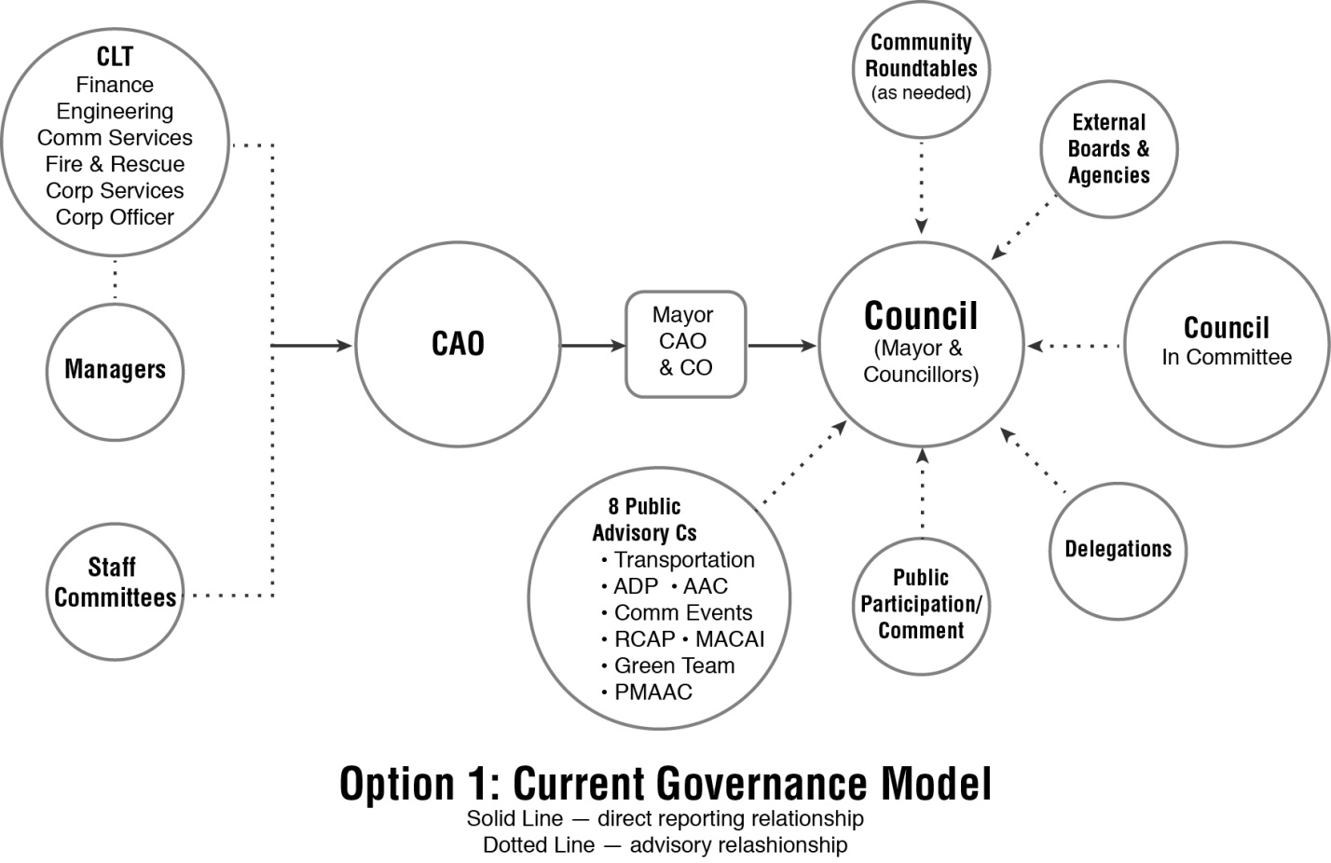

15.2 Option Two: Three Standing Committees plus PACS
A second possible option for the City would be the creation of three standing committees consisting of Council members (with the possible addition of public members) supplemented by the current public advisory committees (e.g. PMAAC, AAC). Council would have to determine whether or not it should appoint Councillors to the PACs as this model would work in either instance. We do not feel that appointing Councillors to the current public advisory committees is needed as these would be heard, in any event, in front of the full Council or at a meeting of one of the three standing committees. The standing committees are envisioned as enveloping the major functions of the City so that any key agenda matter would find its way to Council through one of these committees.
It is proposed that the three standing committees (see Exhibit B) would be as follows:

Community/Development Services Committee
The duties of the Community/Development Services Committee shall be to review and report to Council on all matters relating to, but not limited to, the following:
- Community services (including recreation, facilities, parks policy, programs and sports groups)
- Community group liaison (including allocation of grant funds as applicable to various community groups)
- Cultural matters (including cultural organizations, library operations, seniors centre)
- Planning and development services (e.g. housing, land use, growth and heritage properties)
- Fire services, emergency services, and
- Social Services.

Corporate Economic Services Committee
The duties of this committee shall be to review and report on all matters relating to, but not limited to, the following:
- Council’s financial policies and practices
- Audit schedule and reporting
- Budget approval and monitoring
- Economic development Initiatives
- Investment and debt management issues
- Civic properties
- Information management services and planning
- Strategic planning (including demographic trends and forecasting, priority-setting, annual Council planning); and
- Matters relating to health, safety and insurance.

Infrastructure/Environmental Services Committee
The duties of the Infrastructure/Environmental Services Committee shall be to study and report on all matters relating to, but not limited to, the following:
- Long range capital works
- Environmental services policies relating to waste management, water services, air quality and other environmental issues
- Transportation and transit policy matters; and
- Policy Issues relative to general infrastructure services.

Council could, where conditions seemed to dictate, establish either broader terms of reference or a sub-committee structure such as the one necessitated by the most recent committee creation (i.e. the Community Interface Committee arising out of the recent GEBP development).
It is worthy of note that like Option One, this option also deals strategically with the
Open Government report and the public’s expectation that it would be engaged in matters affecting:
- Programs and services that affect residents
- Capital projects in public areas e.g. roads and buildings
- Council initiatives such as bylaws, policies and projects
- Community planning and development…”
The intent of the three standing committees would be to capture the essence of civic government under three umbrellas such that each committee would have a relatively significant platter of issues to review and discuss prior to recommendations being forwarded to Council. In this instance, the role of the management would be considerably heightened in that most if not all of the agenda matters will arise as a result of management reports (which have been previously vetted by the CAO). While Council could appoint two members of Council plus the Mayor as ex officio to each of these committees, it is entirely likely that all members of Council would want to be present at all standing committee meetings in order to ensure that each Councillor was concurrently aware of every issue.
Like Option One, this Option could also include the establishment of Community Roundtables and could reflect Council’s strategic priorities. The Roundtables would likely be enveloped within a standing committee’s agenda so there would likely be less need for a Roundtable. Councillor Initiatives would unlikely be established as each Councillor would ensure that “their” committee placed such issues of concern to them personally on the agendas.

Exhibit B

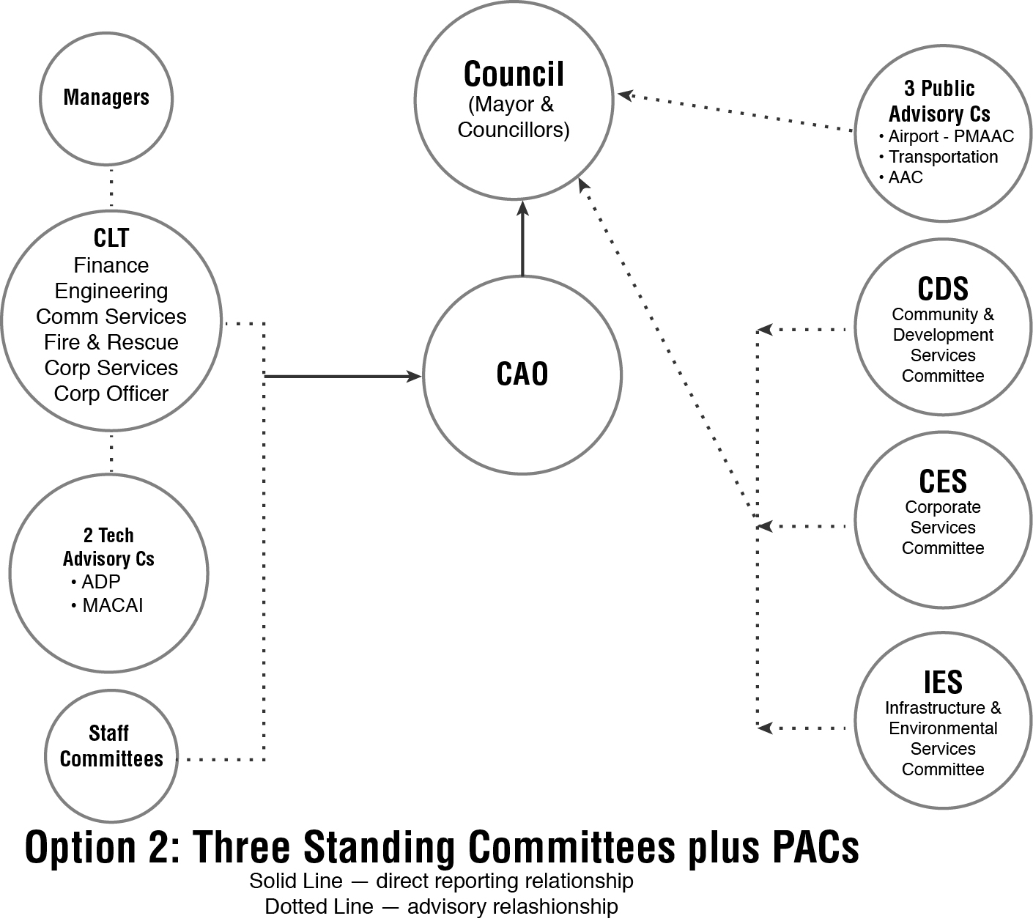

15.3 Option Three: Strategic Priorities Committees
This approach (Exhibit C) would reflect Council’s strategic priorities as determined by its annual planning process. These priorities are born out of Council’s “Vision, Mission and Core Values” and are (2018) clustered into four broadly-based themes. These themes are noted as follows:
- Corporate Excellence
- Economic Prosperity
- Community Livability
- Transportation and Infrastructure.
It is expected that these four themes could be established as either separate standing committees or as the four pillars of the afore-mentioned GPC (Governance and Priorities Committee) or as one standing committee known as “Strategic Priorities Committee”. The first pillar (Corporate Excellence) could accommodate issues which might be described as “governance/policy” matters while the issues related to Council’s proposed direction (strategies) could also fit in that umbrella or others. The second pillar (Economic Prosperity) would likely envelope finance, budget, audit, etc. The third pillar (Community Liveability) would envelope leisure services, planning and development, parks, culture, etc. The fourth pillar (Transportation and Infrastructure) would comprise of all the City’s “hard services” including roads, sidewalks, underground utilities, maintenance, etc.
All other external committees could be required to report through these four select committees. Where issues are brought before Council as separate distinct matters for inquiry, Council could establish “select” committees or task forces which are more “time-sensitive” to deal with such matters.
This model would reflect less stability than the foregoing two in that the mandates would presumably change annually as Council reflects on, and likely changes, its strategic priorities from year to year. While this may appear to be a more nimble approach, it might take considerably more time for the administration to develop a familiarity with how the model is intended to work. It is also likely that the public would need time to become familiar with the model and its strategic priorities and this time lapse may result in a less than successful “feel” to the model.

Exhibit C

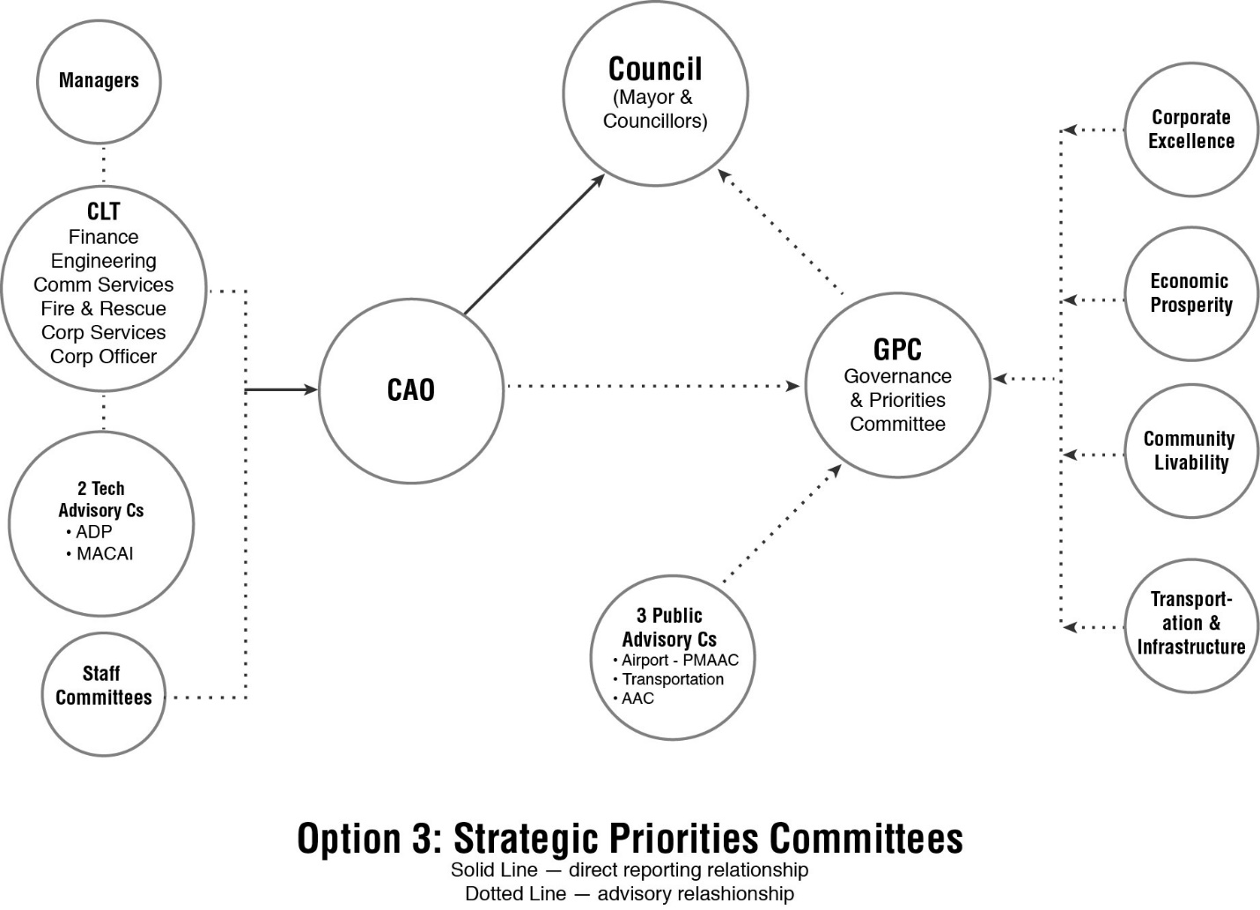

15.4 Option Four: Community Roundtables
In this model (Exhibit D), formal committee structures (to the extent permissible) are eliminated and replaced by extemporaneous “gatherings” on an as needed basis. Such assemblies would need to be carefully structured and timed so as to gain maximum mileage from minimal organization. Thus, and for example only, the fairly recent Round Table on Transportation was deemed to be successful in that it drew together a considerable cross-section of Pitt Meadows residents/businesses to discuss a very significant issue. A first rate paper was produced and circulated and formed the backdrop to the discussions.
Previously, the Roundtable on Open Governance was deemed by most to have been a useful venture in public consultation attracting a broad cross-section of inputs on a significant policy discussion.
In the future, and as another example, Council could call together a “Save PM Agriculture” roundtable and invite experts from the colleges/universities as well as from major agricultural industries, federal and provincial governments, Chamber of Commerce, etc. The “Roundtable” could be hosted over a weekend by Council (and management in support roles) and result in clear statements of support for this or that policy or initiative.
At the conclusion of each roundtable, Council would (likely) see developed a City over-arching policy statement which would then be used to guide Council’s thinking and perhaps decision-making on related matters.
The advantage would be one of short term engagement for a useful product; the disadvantage would be limited to negligible ongoing connections to the Council on related matters.
Roundtables would receive an advantage in that any needed background reports would either be developed by management (CAO/CLT) or by someone contracted for this purpose by the City. Any report going to the Roundtable or from it to Council would be assessed by the CAO/management table such that Council will always have access to the independent, administrative perspectives of its senior management.
Such roundtables would provide a nimble progressive model with limited structure or the time commitments of ongoing committees.
Other “roundtables” might include:
- Roundtable on Sustainable Transportation
- Roundtable on Commercial Expansion
- Roundtable on Leisure Activities
- Roundtable on Community Safety & Policing.
The Community Roundtables model could readily and seamlessly incorporate the Safety and Security Web (SSW) initiative supported by Council. This initiative, begun in 2016, culminated in a community wide forum around seven key themes. Each of those themes could be featured as the topic for a “community roundtable” or could be amalgamated under a broader umbrella topic which has greater connection to the whole community.
In June 2017, Council directed staff to review current City plans for alignment with the safety and security web initiatives, conduct a gap analysis and establish community committees to launch in 2018 to assist with forwarding the safety and security work.
The seven themes identified are as follows:
- Community Safety
- Housing
- Mental Health and Addictions
- Senior Services
- Strong Economy
- Traffic Safety
- Youth/Schools
The disadvantage of the Roundtable concept when applied quite exclusively to Council’s decision-making processes is the gaping holes left between roundtables wherein community issues would arise and not fit a particular table; or may fit a later one but not in a time-sensitive fashion. This would, in our opinion, likely lead to the creation of more community committees to address issues of a longer-standing nature.

Exhibit D
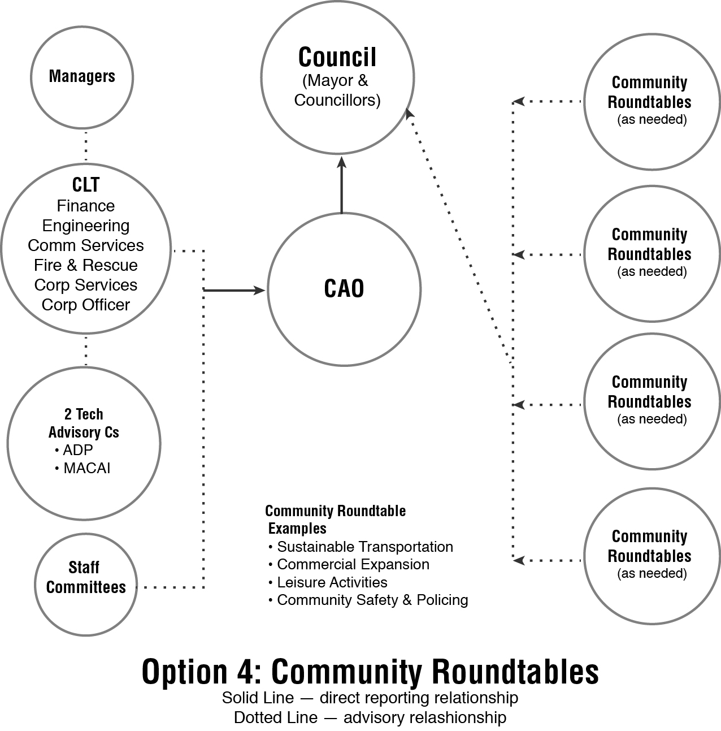

15.5 Option Five: Recommended New Governance Model (Governance & Priorities Committee)
The cornerstone of Exhibit E is the proposed Governance and Priorities Committee. This standing committee consisting solely of all members of Council is proposed to be utilized principally as a “pause and reflect” mechanism which will enable Council to ponder the more significant issues which it will receive on its agenda. The GPC (as a committee of the whole) will consist solely of all members of Council and will be expected to meet, likely on at minimum a monthly basis, to:
- receive all reports from any external bodies (e.g. Council roundtables, task forces or publicly-established committees)
- meet with any delegations (who may also appear before a regular meeting of Council or who may, at the request of Council, be provided with a time slot on a forthcoming regular meeting of Council)
- receive the reports (and meet as appropriate) with the chair of any technical advisory committee or that of a public advisory committee
- meet with all other external legislated bodies who have a right and responsibility to act in an advisory capacity to Council
- receive reports from the CAO (and senior management) and to discuss their implications
- recommend forward to a regular meeting of Council all matters which require the formal resolution of Council.
As a basic premise, all matters of significance and policy import will flow either directly to Council or through the GPC. As a result, there will be no requirement or commitment on behalf of Council to appoint any of its members to other advisory bodies (except as might be required by other statute or commitment e.g. MACAI). Any committees will make appointments with the Corporate Officer to be heard at a GPC meeting and will be placed on this agenda. This system eliminates the necessity of individual Councillors serving on community-based committees given that anything on their agenda which needs the endorsement of Council (i.e. in order to be considered a City policy) will appear before all of Council at a GPC meeting. Having Councillors appointed to any public advisory committees or other community agencies created by the public will be understood as unnecessary if this model is utilized as designed and anticipated. We note that this does not prohibit a Councillor (on a matter of personal choice) from attending these or other community committees and boards nor does it stop the Mayor from appointing a Councillor as a liaison to such entities from time to time and for a specific purpose. This will, however, not be necessary as any issue to come before Council will still need to be addressed to and reviewed at the GPC.
Given that management will be expected to author background reports for the GPC meetings and Council meetings could eliminate their requirement to be in attendance at any public advisory committees. This would be a flexible arrangement as such committees could request the advice/input of management/staff experts but this would be on an “as requested” basis.
Of importance, we believe, is the Open Government report which was endorsed by Council and which addressed itself to a number of key themes. The City accepted this report and also developed a “Declaration of Open Government Principles” which it signed off on December 1st 2015. The public made it clear that it expected to be engaged in matters affecting:
- Programs and services that affect residents
- Capital projects in public areas e.g. roads and buildings
- Council initiatives such as bylaws, policies and projects
- Community planning and development…”
This recommended model (i.e. Governance and Priorities Committee Plus) has a number of related components enveloped within its structure such that the Council will have the luxury of seeking opinion in and out of formal structures. These component parts enable the Mayor and Councillors to hear from a variety of audiences on various topics of local concern; to ask a specific roundtable for its advice on a single policy topic; to charge one member of Council with the responsibility to investigate a particular issue which is of importance to the whole Council; to ensure that its strategic priorities are considered and are addressed in a particular year(s).

15.5.1 Community Roundtables
This GPC model anticipates that Council will likely make good use of community roundtables on matters of civic import (e.g. Official Community Plan review, Parks and Recreation Master Plan, etc.). As this strategy has apparently worked well (i.e. Transportation Roundtable) we see no reason why it could not be utilized judiciously by Council and management within the GPC model. Any report emanating from a Roundtable would be referred firstly to the CAO and his CLT for their review prior to being tabled at GPC. This will ensure that all such initiatives are placed in a much broader context and considered by Council as a whole in a more informal atmosphere than a regular meeting of Council.

15.5.2 Councillor Initiatives
As described elsewhere in this Report (see Sec. 16.3), Council may utilize a “Councillor Initiative” model and have anyone so assigned a particular task to report on a specified schedule back to the GPC. Again, this Model ensures that Council members are afforded the opportunity to receive and review reports of significance before they are tabled at Council.

15.5.3 Strategic Priorities
Whereas Option Three describes this as a model unto itself, Council could make use of its strategic planning mechanism to identify the key annual priorities and make these an ongoing element of a GPC meeting. Thus, the agenda for a GPC meeting (see Appendix I) could reflect Council’s key strategic priorities as ongoing agenda items which would serve as a reminder that these were identified by Council as important and therefore ought to be pursued.

Exhibit E
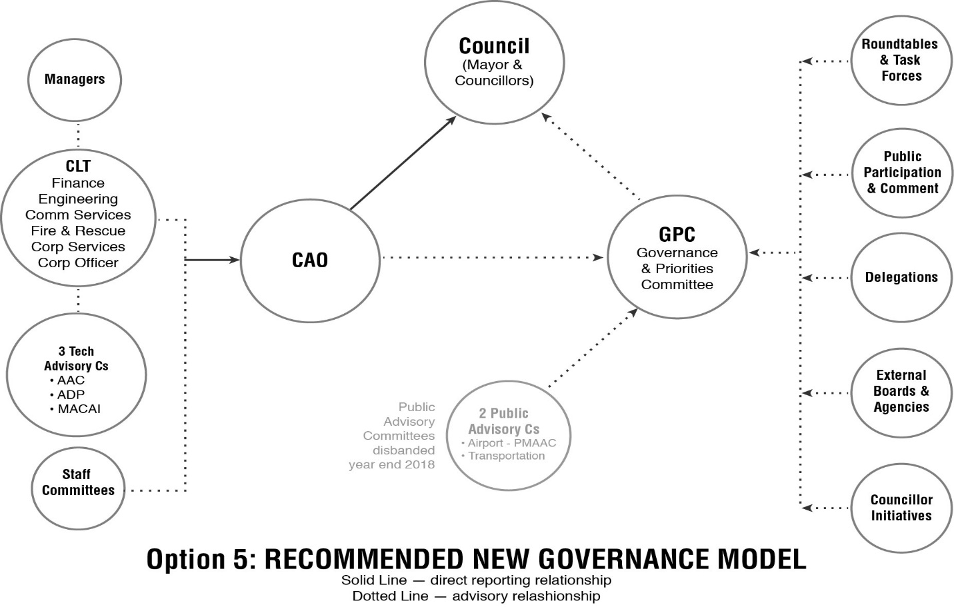

16.0 The Recommended Model
Based on our extensive review of the current model of governance and that used by other municipalities of a similar size, we believe and are recommending the following enriched governance model (known as the “Governance & Priorities Committee Plus”) (GPC) for Council to consider and adopt. This has a number of inter-dependent parts requiring that each be adopted and implemented and accepted for a minimum of 9-12 months to give the new system a fair trial.
The component parts to this model are as follows:

16.1 Governance and Priorities Committee (GPC)
The GPC is expected to become a very important component of Council’s decision-making as Council gains familiarity with its usage. The GPC is NOT intended to be an extension of a Council meeting. It will have a distinctly different agenda which may feature only one or two priority business items which will also appear on the regular Council meeting agenda. In addition, it may include sections of the agenda through which various public advisory committees will report. For example, the GPC agenda for such meetings (which will be open to the public) may include specific sections as follows: a Reports and Delegations (e.g. Public Advisory Committees) section; a Public Participation and Comment section; a Parks, Infrastructure and Transportation section; a Planning and Environmental Services section; a Finance, Audit and Corporate Services section; a Community, Cultural Services and Engagement section; and other.
The GPC could be utilized as well for dealing with an initial review of issues which individual Councillors have asked to be placed on the Council agenda. The current approach to ensuring that a Council member is able to gain access to the agenda for an issue of their concern is covered by your Procedure Bylaw (the applicable sections follow):
- Section 15(2) of the Bylaw states:
“An item from a member of Council for an agenda is submitted in writing to the Mayor in the form of a report containing relevant explanatory information and background, and shall be signed by no less than two Council members; the Mayor shall place the report on an agenda as soon as reasonably possible, and Councillors’ reports will be listed in the order in which they are submitted.”
- Section 25 of the Bylaw states:
During the New/Other Business portion of a regular or special meeting of the Council, any Council member may give a “Notice of Motion” respecting an item which he or she intends to present at a future meeting, upon the member being acknowledged by the Presiding Member and the Notice of Motion being read to the meeting.
A written copy of the motion presented under Section 25 shall be provided to the Corporate Officer for inclusion in the Minutes of that meeting as a “Notice of Motion”. The Corporate Officer shall place the motion on the Agenda of the next regular or special council meeting, or other future meeting designated by the member bringing forward the Notice of Motion, for consideration.
The GPC should also be used by Council as an opportunity to hear from potentially a wide array of speakers on topics of some concern locally but on which the Council has yet to take a strong policy position. In such instances the Council may decide to take no action or to simply pass a motion to accept such inputs “for information”.

16.2 Terms of Reference
The following are proposed as the appropriate terms of reference for the Governance & Priorities Committee. The GPC may:
- Hear from delegations and/or refer these on to Council
- Review matters forwarded to it by the CAO or by Council
- Consider matters placed on the agenda by the CAO, by other members of Council; ensure that all such matters are previously referred to the CAO for a report
- Refer any matter on to a regular meeting of Council which is not the subject of current policy (including new statements of policy)
- Review reports or minutes from external boards and committees so that there is some degree of consistency as to how each is treated by the Council
- Meet publicly at least monthly at a time which is deemed by a majority of Council to enable any interested public to attend
- May determine to meet in-camera on a vote of the committee at the conclusion of a meeting; in-camera matters are limited as per the legislation
- Meet principally as a forum for discussion rather than as a decision-making arena (enables all of Council to review and discuss key issues without the requirement to decide)
- May refer an item to the CAO for more information or clarification but must move the issue forward to Council for its consideration and decision upon receipt of the clarifying information (in other words, the referral process if used is intended to be limited on a normal basis to two weeks).

16.3 Councillor Initiatives
A third interdependent link which the Mayor and Council might find useful is described as “Councillor Initiatives” which will be key topics which the City would like to investigate further or be seen to raise the awareness of the matter. As such, a Councillor might be appointed as Council’s main spokesperson on “Farmland Protection” or “Highway Safety” or “Salute to Volunteers” or whatever a key theme or initiative happens to be. These would be external to the normal business of Council and of its current committees and would be considered a “one off”. The Councillor so named would be appointed by the Mayor with a set terms of reference and a sunset clause by which time the initiative will have been deemed to have been completed. It would be very unusual if the term of a Councillor Initiative is longer than one year.

16.4 Public Advisory Committees
A fourth component for inputs to Council are the advisory committees which Council has presently; at least one of which could continue to function but under a particular umbrella known as “Public Advisory Committees”. As it stands at the moment, we believe that the logical candidate to be placed in this umbrella would be the Agriculture Advisory Committee. This committee deals with policy issues at they affect Pitt Meadows agricultural base (which is extensive) and matters relating to agriculture land commission applications and development proposals; irrigation, drainage and other water management; raising awareness and enhancing the understanding of agriculture’s role in the economy and improving opportunities for joint funding; also appears to have the liberty of discussing what it sees as related matters including invasive species, the sustainability of farming, etc.
This committee will advise Council likely through the GPC or to a regular meeting of Council. Either process will gain the ear and attention of Council (with more clarity likely at the GPC level as that agenda will be less crowded than a regular Council meeting agenda). In each instance, the minutes of the AAC will be reviewed at minimum by the CAO prior to being dealt with by Council to ensure that Council has access to the CAO’s input insofar as current policy or budget are concerned.
* It is our understanding that Council will be advising the Airport Board that it ought to develop more of a “public face” to its functions and that the current (or revised) Airport Public Advisory Committee could adequately fulfill such a purpose. There is nothing to stop the Airport Advisory Committee from filing reports with Pitt Meadows Council but it would likely have considerably more impact should the Airport Board seek its advice from time to time.
We note that while the Airport Advisory Committee may add some value to the Mayor and Councillors, it is hard to justify its existence when there is a legally constituted board with the mandate of overseeing the Airport. It would make more sense for Council to recommend to the Airport Board to establish some form of public advisory process such that these voices could be heard at a table where the appropriate people are assembled and capable of making decisions. There are also other alternatives: a “Transportation Advisory Committee” could be established with broad terms of reference which would include air, land and water course travel. However, we believe that the Roundtable on the Future of Transportation in Pitt Meadows (June 25th 2018) is a more useful and focused mechanism for such community-wide issues.
As long as such community-based committees exist, they ought to report through the GPC to Council, where their voices would be heard on a more regular (meeting by meeting) basis. As we noted in the draft report, Council might also hear from the larger public as to their views on specific matters related to the advisory committees through such a forum as a “community roundtable”. If Council is determined to retain the present suite of public advisory committees then changes would need to be made to their type and frequency of reporting to Council if any ongoing relevance and value is expected.
We were advised that the mandate of the Active Transportation Committee is largely administrative in nature and while useful could fit readily within the role/purpose of the “technical advisory committees”. While we do not foresee the need for a Councillor to serve on this committee as any related governance/policy matter would be reported through to the GPC, this does not mean that the Mayor cannot appoint a Councillor to a liaison role with the committee. While this placement might have appeared to some to have relegated the importance of the ATC, that was not the intent. It was to properly place committees which are following Council policy and which are focused on ensuring effective implementation by the administration.

16.5 Technical Advisory Committees
Technical Advisory Committees are those which are focused on a particular administrative function and one which is likely already the subject of a Council policy. While there may be some policy-related discussions, the focus (as we understand it) is on the more administrative and technical aspects. Their discussions and deliberations provide some value which appears to be more core to the work of City management. In the proposed model, these committees would be heard individually through the GPC as a forum and would be expected to report at least once annually. Thus, these reports should be circulated through the CAO for an administrative review prior to being considered by the GPC. These TAC are recommended as the:
  - Advisory Design Panel
  - Municipal Advisory Committee on Accessibility & Inclusiveness
  - Active Transportation Public Advisory Committee..

16.6 Roundtables
A fifth potential mechanism for providing input to Council and one which has been utilized previously to good effect are the “community roundtables”. This informal structure utilizes assemblies of interested citizens on an “as needed” basis to discuss the issues pertaining to a significant community issue. The “roundtable” concept has the advantage of being short term and focused without the necessity of ongoing meetings and staffing to support another structure. The principal disadvantage if used alone is that a Roundtable by its very nature does not capture all of the key issues facing a Council and thus a number of other unrelated issues would likely fall by the wayside. The potential, however, to explore one significant issue in depth and recommend a policy position forward to Council makes this a very attractive mechanism.

16.7 Task Forces
Council may, from time to time during the course of a term, identify an issue of substance which has a fairly narrow focus (unlike a Roundtable) and which is time-sensitive (i.e. will be completed within say 90 days). In such an instance, Council could structure a “task force” of a small, select group of citizens to review the issue (likely supported by relevant staff) and provide a report to Council by a certain date. The key to this mechanism (and likely to all) is the need to create particular terms of reference to guide the task force to ensure that what Council is looking for actually gets addressed.
16.8 External ABCs
Pitt Meadows Council is asked to make appointments of one or more of its members to a variety of external agencies, boards and committees. These are identified in Appendix A and are largely regional in nature e.g. Fraser Valley Regional Library Board. Their meeting minutes ought to be routed through the office of the Corporate Officer who will ensure that these or a summary thereof are brought to the attention of Council on a timely basis.

17.0 Key Support Roles

17.1 Role and Impact of the Chief Administrative Officer
As in all administrative matters being recommended to Council, we view the CAO as a core element in this discussion. He is regarded as Council’s chief policy advisor and for that reason his advice should be sought on any matter being forwarded to Council for its consideration. The principal advisor to Council and the Governance & Priorities Committee is the CAO. Whether or not other management (or other staff other than the corporate officer) is in attendance is the prerogative of the CAO.
The primary role of the CAO as always is to act as the policy advisor to Council and to ensure that Council has access to well-rounded information that adds to its understanding of the issues. During a GPC meeting, the CAO should be engaged frequently by Council in terms of responding to questions or by directing the questions of the Councillors to other appropriate members of his administration.
When a topic is opened by the Mayor to the table (i.e. to the rest of Council in attendance) for its discussion, the best approach would be for the Mayor to ask the CAO if he had any additional or new information to add prior to opening the floor to members of Council (or even to the public). The CAO may then re-direct the question to the senior staff member most impacted by the topic or under whose jurisdiction the topic fits. Providing that it is always deemed acceptable for the CAO to intervene in an administrative presentation, once he has deferred in his initial remarks to a department head, the members of Council should be permitted to continue their questions to that individual. (This is a departure from the protocol at a regular meeting of Council where members should be asked to direct all questions of administration to the CAO).

17.2 Role of Senior Management
One of the impacts of any system of governance is the work required by and expected of the senior management group, known locally as CLT (Corporate Leadership Team). The members of the CLT are the City’s most senior and experienced employees with applicable academic backgrounds which justify their membership in such a group. As a team, the CLT has an important series of roles to play, not the least of which is its advisory role to Council. Each report destined for Council’s agenda is required to pass the desks of this group with these managers expected to place their comments and approval on each item before Council members review and determine the fate of these matters. Thus, while Council decides, CLT advises.
We point this out as the use of their time is valued and their presence is expected wherever Council is reviewing agenda matters and rendering decisions (i.e. at meetings of GPC and Council). As such, their availability to serve as advisors to any ongoing public advisory committees will be limited. Those asked to serve in an advisory role (for whatever limited time) to such committees need to be those who report to the CLT and for whom such experience would be invaluable as they progress in their careers.
This is not to suggest that CLT members will not be directly involved in the advisory processes to Council. The alternatives as designed will require the advice and likely presence of senior management in any reporting to Council by external mechanisms. Thus, each of the five alternatives carry an expectation of senior management playing an advisory role when matters are scheduled to be presented to Council. Whereas less senior staff could likely be the administrative focal point for the “Community Roundtables” the other alternatives would see the CLT at the management table for each meeting.
Further, the Corporate Officer will be responsible for staffing the support functions at each meeting of Council, GPC, Community Roundtables or any other Council-established initiative under the terms and conditions described in this Report. It should be up to the CAO as to which management staff are to be present at any committee meeting and if so, which one(s).
The alternative to this model is to continue to provide staff resources to these meetings on a once monthly basis. If this is to be the case, then the terms of reference for such support needs to be carefully conveyed to the ABCs so that staff resources are not taken for granted or utilized in a manner not expected or perhaps even permitted by the City.

17.3 Enhanced Role of the Corporate Officer
As this Report underlines, the role of the Corporate Officer is critical to the potential success of any governance model. The reader will note that we have outlined a number of very specific and somewhat time-consuming roles for the CO which will be necessary if Council’s governance model is to function successfully. While the “expert” advisor will still be presumed to be appointed by the respective department, the CO should be viewed as the central core person in the management of all such meetings and the provider or coordinator of any secretarial support (which may be delegated to the respective departments). Regardless of who the SME (subject matter expert) is, the coordination of minutes and agendas will still flow through the office of the CO.

17.4 Administrative Review of Agenda Issues
While the agenda and tone of a GPC meeting is not as formal as that of a regular meeting, the quality of any debate will depend on the quality of the input. This requires that the CAO and his department heads as appropriate establish their own timeline such that a meeting of the Corporate Leadership Team (CLT) occurs several days prior to the Mayor, CAO and CO who will review any agenda for the GPC and Council.
The key for the CAO and his CLT is to keep the focus on the broader and more strategic issues. The key determinants of whether or not an issue goes forward to the GPC meeting should incorporate consideration of:
- Is this a matter that we require Council’s endorsement of?
- Is this a matter of a new or a revised policy?
- Does the issue have broad community significance?
- Is this an issue that it can be reasonably argued that Council would expect to see and provide direction to even though it may be within the parameters given to the CAO to act?

18.0 What Will Change?
One of the most anticipated questions that Council could expect to hear will be: what will actually change? Perhaps it is easier to address that question by answering firstly, what will not change? In this regard, the following will remain as it is today:
- Council will ultimately be in charge of making the policy decisions for the City
- The senior administration, led by the CAO, will continue to be Council’s most evident and hopefully trusted policy advisor
- Council will be keen to do well for its citizens; it is committed to serving the City well
- The public’s opinions will be sought and listened to by Council; the impact of those voices will vary from issue to issue
- Meetings will be held and decisions rendered.
What will change? We believe that the following changes will be recognized based on the adoption of this Report:
- The flow of information to Council will be more predictable and better coordinated; Council members will be better informed and in a timely manner
- The voices of the public will be better heard; there will be more avenues for public expression
- Councillors will better understand how they might get an item onto the agenda
- Public committee reports will be heard and where appropriate, acted upon
- Community roundtables will be used with greater frequency on matters of some significance
- The time of senior management will be better focused at the GPC stage than is currently the case
- Citizen input on matters which are more administrative in nature (e.g. curb cuts to facilitate ease of passage for wheelchairs; the placement of garbage receptacles on public pathways) is best channelled through a structure placed under the guidance of the administration but yet which will be expected to report through the GPC to Council whenever Council’s approval or direction is required
- Individual Councillors may be given increased priority on specific issues as a series of “Councillor Initiatives” are rolled out by the Mayor; the themes identified by the Safety and Security Web initiative may be assigned to specific Councillors to champion or may be developed further as a result of Community Roundtables
- Council’s strategic priorities will be on the monthly GPC agenda and thus the Council agenda; this will ensure that the strategic planning exercise undertaken by Council will have considerably more “teeth” to it than previously
- Community groups will continue to spring up related to specific issues and will be handled expeditiously by Council through the mechanisms created as a result of this Report
- The Mayor and Councillors will be reluctant to recommend the establishment of other committees recognizing that such committees will further stretch the finite resources of the City.

19.0 Recommendations
- Report Adoption:
  - We recommend that Council adopt this Report “in principle” as its statement that it has been received and can be circulated for comment.
- Re-Design
  - We recommend that Council agree to a complete re-design of its agencies, boards and committees in order to better focus its energies on the policy matters which ought to be considered of higher importance and thus delegate the day to day matters to the administration of the City.
- Governance and Priorities Committee
  - We recommend that Council rescind the Council in Committee (CIC) and create a revised committee of the whole to be known as the “Governance and Priorities Committee” (GPC).
  - We recommend that the agenda for a GPC meeting be such that the focus is placed on those key policy topics identified largely by the Agendas Committee (i.e. Mayor, CAO, CO). Such meetings thus may only have two or three larger or more controversial or important items on the agenda rather than reflect a replica of a regular Council meeting. (As a second alternative, Council and administration may wish to structure such meetings in such a way that the agenda for such meetings (which will be open to the public) will include specific sections as follows: Reports and Delegations section; Public Comment/Question Period section; Parks, Infrastructure and Transportation section; Planning and Environmental Services section; Finance and Corporate Services section; Community, Cultural Services and Engagement section; key Councillor priorities; and other.
  - We recommend that a bylaw be created for the establishment of the Governance and Priorities Committee.

- Code of Conduct
  - We recommend that the Code of Conduct for ABCs and other public engagement mechanisms created or authorized by Council be referred to the CAO for review; that once that has been completed that the Code be adopted by Council and distributed to any ABCs (Appendix B) impacted by the Code.
- Technical Advisory Committees
  - We recommend that the Active Transportation Committee be adopted within the Technical Advisory Committee structure and report through that process to the GPC.
  - We recommend that the following committees be declared “technical advisory committees”; that their terms of reference (or establishing bylaw) be rescinded or revised to reflect that the purpose of the committee is to advise the applicable management of the City (with an Annual Report being submitted to Council). These committees in this category are recommended as:
      - Advisory Design Panel
      - Municipal Advisory Committee on Accessibility & Inclusiveness
      - Active Transportation Advisory Committee.
- Public Advisory Committees
  - We recommend that the current Agriculture Advisory Committee continue in its present form; that Council appoint a representative to serve as a liaison to this committee; that the minutes of the AAC be provided to Council (through the GPC) as quickly as possible after each committee meeting; and that the chair of the AAC be issued a standing invitation to attend and present to the GPC or Council the committee minutes or request for action emanating from such minutes.
  - We recommend that at present the committee in this category be designated as the Agricultural Advisory Committee; and that the committee consist of other public advisory committees as might be established (or recognized) by Council from time to time).
  - We recommend that Council request the Airport Board to give consideration to amending its governance structure so as to include public representation through an advisory committee of affected residents and landowners. This would negate the need for a separate Pitt Meadows Airport Advisory Committee (PMAAC).
- Pitt Meadows Day Society
  - We recommend that the Pitt Meadows Day Society as an independently established “society” under the Society Act of BC, also be invited to liaise with Council from time to time and update Council on its plans for the upcoming PM Day. As a separate (i.e. non-City body) the Society has the right to request Council or staff membership on its governing or management body. As an event-style organization, Council’s logical role would be to assist through annual funding and by ensuring that the CAO has designated the most appropriate member of management to assist the Society. Other than as a matter of personal interest, there would not appear to be any need for a member of Council to attend such meetings of this Society given that its work/mandate is largely administrative.
- Staff Committees
  - We recommend that the following committees be designated “Staff Committees” without any need for Council or public representation:
      - Community Events Liaison
      - Green Team Committee
      - Rail Community Advisory Panel
- Meetings
  - We recommend that Council meet in regular Council meetings on the second and fourth Tuesdays; and that it meet at least once monthly (unless as otherwise determined by Council) as the Governance and Priorities Committee.
- Principles
10.1 We recommend that the ABC operating principles be adopted by Council.
- Procedure Bylaw
  - We recommend that the Council Procedure Bylaw be reviewed and revised to capture the essence of this Report.

Respectfully Submitted,

George B Cuff, FCMC
President
George B Cuff & Associates Ltd.

Appendices


Appendix A: External Committees

2018 Council Liaison Appointments (Outside Bodies and Committees)
EXTERNAL COMMITTEES
Alouette River Management Society  (as req’d) | Liaison  Alternate | Councillor Mike Stark  Councillor Janis Elkerton
Chamber of Commerce - Maple Ridge/Pitt Meadows  (4th Mon 5pm) | Liaison  1st Alternate  2nd Alternate | Mayor John Becker  Councillor Janis Elkerton  Councillor Mike Stark
Emergency Program Liaison Committee  (Quarterly) | Liaison  Alternate | Councillor Tracy Miyashita  Councillor Mike Stark
Fraser Basin Council Integrated Flood Hazard Management Committee Advisory Council  (4th Wed) | Liaison  Alternate | Councillor Janis Elkerton  Councillor Bruce Bell
Fraser Health Municipal Government Advisory Council  (Quarterly) | Liaison | Councillor Tracy Miyashita
Fraser Valley Regional Library Board  (4th Wed) | Member  Alternate | Councillor Bill Dingwall  Councillor Mike Stark
Joint Police Liaison Committee  (as req’d) | Liaison  Alternate | Councillor Bill Dingwall  Councillor Janis Elkerton
Lower Mainland Local Government Association  Flood Control and River Management Committee  (3rd Wed) | Member  Alternate | Councillor Mike Stark  Councillor Janis Elkerton
Maple Ridge - Pitt Meadows Agricultural Association  (as req’d) | Liaison  Alternate | Councillor Bruce Bell  Councillor Bill Dingwall
Maple Ridge - Pitt Meadows Community Services Council  (as req’d) | Liaison  Alternate | Councillor Tracy Miyashita  Councillor Mike Stark
Mayors Council on Regional Transportation (TransLink)  (monthly; last Thur or Fri) | Member  Alternate  Alternate | Mayor John Becker  Councillor Mike Stark  Councillor Janis Elkerton
Metro Vancouver – Aboriginal Relations Committee  (1st Thurs, 1pm) | Member | Mayor John Becker
Metro Vancouver - Board of Directors  (4th Fri; 9am) | Director  Alternate | Mayor John Becker  Councillor Janis Elkerton
Metro Vancouver – Mayors Committee  (March/July/October; 1pm) | Member | Mayor John Becker
Metro Vancouver – Regional Parks Committee  (monthly; Wednesdays; 9am) | Member | Councillor Janis Elkerton
Metro Vancouver – Utilities Commission  (2nd Thurs; mornings) | Member | Mayor John Becker
Municipal Advisory Committee on Accessibility & Inclusiveness (MACAI) (3rd Thurs; no meetings July, Aug or Dec) | Liaison  Alternate | Councillor Bruce Bell  Councillor Janis Elkerton
Pitt Meadows Airport Interim Board of Directors  (4th Wed; evenings) | Director  Director  Director | Mayor John Becker  Councillor Bruce Bell  Councillor Mike Stark
Pitt Meadows Day Society  (3rd Mon) | Liaison  Alternate | Councillor Bruce Bell  Councillor Janis Elkerton
Pitt Meadows Heritage and Museum Society  (2nd Wed) | Liaison  Alternate | Councillor Mike Stark  Councillor Bruce Bell
Ridge Meadows Seniors Society  (3rd Thurs) | Liaison  Alternate | Councillor Bruce Bell  Councillor Janis Elkerton
UBC Malcolm Knapp Research Forest Community Advisory Board  (as req’d) | Liaison  Alternate | Councillor Janis Elkerton  Councillor Mike Stark
United Way of the Lower Mainland  (as req’d) | Liaison | Councillor Janis Elkerton  Councillor Tracy Miyashita
Maple Ridge Pitt Meadows Youth Centre Society  (as req’d) | Liaison  Alternate | Councillor Mike Stark  Councillor Janis Elkerton

Protocol Chart for Council Appointed bodies
Type of Body | Established by | Make Up | Appointments by | Legislation | Limits | Authority | Term | Staff Liaisons
Standing | Mayor | Half must be members of Council; may include citizens | Mayor, including appointment of Chair and Vice Chair | Community Charter  S141 | Advisory body to Council for matters Mayor considers better dealt with by committee | Make recommendation of Council for approval | 4 years, or as set by Council | Appointed by CAO
Select | Council Resolution | Council members (at least one); may include citizens | By Council; including appointment of Chair and/or Vice Chair | Community Charter  S142 | Advisory body to Council for matters Council considers better dealt with by Committee can include time limit | Make recommendation of Council for approval | 4 years, or as set by Council | Appointed by CAO
Advisory | Council Resolution | Council members (at least one); may include citizens | By Council; including appointment of Chair and/or Vice Chair | Community Charter  S93 | Advisory body to Council usually on broader issues, like Parks & Rec | Make recommendation of Council for approval | 4 years, or as set by Council | Appointed by CAO
Commissions | Council Resolution | Citizens; may include Council members; appointment of Chair & Vice may be by Council, constituted by bylaw | Council Resolution | Community Charter  S143 | To operate services; and/or regulate, prohibit or impose requirements as delegated by Council; and/or manage property | Independent exercise of Council’s authority as delegated by Council by bylaw | 4 years, or as set by Council | Appointed by CAO
Task Force | Council Resolution | Citizens; may include Council members; appointment of Chair and Vice may be by Council | Council Resolution | Community Charter  S93 | Usually appointed for a specific purpose | Reports findings to Council | Short-term until task complete | Appointed by CAO
Statutory | Statute and Bylaw | Bd. Of Variance, Reg. Dist. Appointment, Library Bd. & possibly others by statute | Council Resolution | Various as applicable | Serve arms-length in behalf of in cooperation with the municipality | By statute, bylaw, and policies of enabling body | Statute or bylaw | Appointed by CAO
General Protocol for Sub-Committee appointments
Sub-Committee | Parent Committee | Citizens, may include Council members | Parent Committee | n/a | Committees advises Council of making and purpose of sub-Committees and working groups | Make recommendations to parent Committee | Short-term until talk completed | Appointed by CAO
Working Group

Appendix B: ABC Code of Conduct
General Principles
1. All ABC (“Committee”) members are viewed as adding value to the decision-making of the City of Pitt Meadows.
- Council will to the extent possible and timely request and consider the advice provided by a committee so appointed by the Council.
- Members of a committee will always act in a manner which reflects respect for other members, those appearing before the committee, and any staff members in attendance.
- Every committee member will always take a “what’s in the best interests of the City of Pitt Meadows” perspective to all decision-making.
- All applicable laws and local bylaws will be upheld by all members.
- All members will act in an ethical manner in the conduct of their duties.
Conflict of Interest
(See Sections 100-108 of Community Charter that includes provisions for ethical conduct combined with breach penalties, defences and exceptions)
- Any member who believes that he/she has a conflict of interest in a matter on the committee agenda will declare that to the Chair of the meeting and to the clerk of the meeting either before the meeting commences or before the item on the agenda is spoken to which bears a conflict for the member. The member shall then leave the room where the meeting is being held for the duration of time taken to consider that item. (Community Charter, Section 100 (2)
- No member shall give preferential treatment to anyone appearing before a committee.
- No member shall use their involvement as a committee member to profit from any advance knowledge of a proposed development or sale of land involving the City and its business. (Community Charter, Section 108)
- No member shall discuss or vote on any matter where he/she has a conflict in the matter as a result of an employment relationship, a partnership or consulting relationship, or any other relationship which would breach the impartiality of the committee.(Community Charter, Section 102)
- Where the chair of the committee is made aware of a potential conflict involving a committee member then he/she must advise the member before the meeting and requests that the member consider stepping aside during the discussion of that item. The decision whether or not to declare a conflict is up to the individual Section 100(2) per common law.)
Confidentiality
- Section 89 of the Community Charter provides that all meetings are open to the public. This rule is subject to exception as stated in Section 90 which authorizes Council (or a Committee of Council) to convene into a closed meeting. Community Charter Section 117 imposes a duty to preserve the confidentiality of records and information that has been treated as “confidential”. Closed meetings are subject to preserving the confidentiality of information unless a motion is passed to release such information into the public realm because it no longer requires such confidentiality (no longer considered to be of harm if released).
- The committee must pass a motion to declare an item public if it has been circulated as confidential or been the subject of an in camera meeting and discussion (as per section 13 above).
- Where the committee is uncertain as to how to handle such an item, the chair will request the advice from the Corporate Officer of the City; that advice shall be based upon legislation, common law practices, bylaws, policies and parliamentary rules.
Conduct at Meetings
15. No member will be verbally or physically abusive towards any staff member or member of the public or proponent appearing before the committee.
16. Committee members shall always show respect for any staff in attendance and any reporting that they provide to the committee. All such reporting will be deemed to meet the standards which govern a staff member’s professional code of conduct.
17. All members shall conduct themselves showing respect for each other, their opinions and their right to be heard.
18. The reports of staff may be questioned but not ridiculed.
19. The decisions of the committee will not be undermined or ridiculed by a member once the decision has been made (Section 153 of the Community Charter discusses no interference with Staff and Section 115 discusses Responsibilities to Community).
Transparency
20. All meetings shall be open to the public unless permitted by Section 90 of the Community Charter to be held in camera.
Attendance
21. All members are expected to be in attendance at committee meetings to which they have been appointed.
22. Any member who is not able to attend is required to inform the secretary assigned to that committee of their inability to attend.
23. Any member who misses three consecutive meetings without authorization by the committee to do so will forfeit their seat on the committee and will be notified by the City of this action (This is dealt with under section 125(5) of the Community Charter).
Media Coverage or Publicity
24. All matters of the committee shall be dealt with by the committee members.
25. No committee agenda item will be released to the media by a committee member. Such requests will be deferred to the appropriate staff member at City Hall. Public Committee and Council Meeting agendas are available on the City’s website as this relates to the Community Charter’s Open Meeting legislation. More particularly policy C063 and C074 deal with Mayor and Council and provide direction on dealing with the media.
26. Members shall not debate the merits of issues on a committee agenda in any social media forums (see Social Media policy).
Gifts
27. Any gift which a member of a committee receives from anyone other than the City (Council or staff) in connection with their role on a committee will be deemed to be a gift to the City and will be identified to and presented to the office of the Corporate Officer.
Sanctions
28. Any member who violates this Code may be subject to immediate dismissal from the committee on a decision by Council; or, if the member is chair, may be removed as chair on a decision of City Council.
29. Any member who violates these provisions of this Code may be suspended by the members of the committee (on a vote of the committee) from their role on the committee and not permitted to attend any subsequent committee meetings until further notification. (This suspension may be appealed to the Mayor who may waive the suspension after an absence of one committee meeting by the affected member).
30. The committee may vote to ask for a public apology or may pass a motion of censure depending on the circumstances and presumed breach of this Code.

Appendix C: ABC Operating Principles

- Principle # One
  - An ABC will be established if that is a requirement of the applicable legislation or an ABC may be established by the Mayor (in the case of standing committees) or by Council (i.e. the appointment of select committees) if it believes that there are compelling reasons to believe that such an ABC will add value to the decision-making process of Council; and Council may appoint a Councillor to an ABC if it believes that its representation will be useful.
- Principle # Two
  - Any ABC established by Council will only be instituted once its terms of reference have been approved by Council.
- Principle # Three
  - Every ABC established by Council will be reviewed as to its continuation at minimum every two years and the ABC, Council members and applicable staff will be surveyed as to the merit of continuing the ABC.
- Principle # Four
  - All ABCs established by Council are to be advisory to the Council as a whole; as a result, no ABC will have decision-making authority over the matters referred to it by the terms of reference unless that is a requirement of the legislation. ABC members are not to be considered the final voice on any matter as that is a right reserved to the elected Council. Any minutes of the ABC being sent to Council should be moved by the Council member appointed to that ABC “for information” prior to any business issues of the ABC being presented “for action”.
- Principle # Five
  - Any Council member appointed to any ABC is there as a liaison only and not as the advocate of the ABC. The role of advocate is presumed to be that of the Chair of the ABC, a position held by a public member of the ABC (unless otherwise determined by Council); Council appointees should not hold executive positions on any ABC. A member of the public should be so chosen by members of the ABC.
- Principle # Six
  - All ABC meetings will be deemed to be open to the public unless stated otherwise; the provisions of applicable legislation (see Sec. 90 of the Community Charter) apply and thus limit the ability of an ABC to move all or part of any meeting in camera.
- Principle # Seven
  - Membership on all ABCs will be reviewed annually by Council or at the time the term of appointment concludes. Candidates for ABC appointment will be recommended to Council by the CAO and Corporate Officer based on pre-established criteria and with the input of the staff advisor and recording secretary; a recommended list of appointments may be made to Council by the ABC; no Council member should serve on any ABC for longer than three (3) consecutive years unless mitigating circumstances have been considered by Council and it concludes that this time frame can be exceeded.
- Principle # Eight
  - The CAO will designate which staff member is to be the primary advisor to which ABC. Any staff member so assigned is to assist the ABC but his/her reporting relationship will remain the same i.e. to their supervisor in City Hall. No ABC member has the authority to require staff to take action on ABC recommendations.
  - The staff advisor will ensure that the agenda has been circulated and will forward a copy of the minutes to the next regular meeting of the Council. If the ABC wishes to present any matter to Council, that will be done by its Chair.
  - All management reports going to an ABC established by Council will be first reviewed by the respective department/division head.

- Principle # Nine
  - All ABCs shall meet in regular meetings no more frequently than once monthly and no less frequently than quarterly or at the call of the chairperson; only ABC members shall have a vote. The Mayor may have a vote as an ex officio member if so designated and permitted by Council policy.
- Principle # Ten
  - No ABC is authorized to speak directly to the media on any topic under consideration by the ABC. The Media play an important role in providing information to the public on matters of civic interest; the City’s communications staff ensure that Media requests are directed to knowledgeable staff designated as spokesperson(s) for their department or division.

Appendix D: ABC Checklist

- Purpose Statement/Mandate
- Terms of Reference
- History
  - When did ABC Begin
  - Why
- What Authority Does ABC Have?
  - To advise/to decide
- Membership
  - Members
  - Ex Officio
  - Staff Advisor
  - Recording Secretary
  - Term of Members
    - Notification of Term Limit
- Meetings
  - How Often
  - What Dates
  - What Time of Day
  - Quorum
- Appointment Process
  - Advertising
  - Criteria
  - Review of Applicants/By Who/Timing
  - Recommendation to Council
  - Council Discussion/Motion/Vote
  - Candidates Notified
- Orientation
  - Requirement before Attendance
  - Who Coordinates
  - When
  - What Topics
- Training of Chair
  - Requirement
  - Objectives
  - What Procedures
  - By Who; When
  - Follow-up
- Public Access
  - Meetings Open Unless…
- Minutes
  - Taken; By Who
  - What Style
  - When Available to:
    - Council
    - Committee Members
  - When Posted to Website; by Who
  - What Training for Committee Secretaries/Advisors
  - By Who
- Committee Secretariat
  - Housed in/Responsibility of

Appendix E: Guidance to ABC Members (Current Structure)
The responsibility for all agencies, boards and committees rests with the Corporate Officer. While some of the associated duties will no doubt be delegated, the responsibility for their “management”, monitoring and clerical assistance should be lodged with the Corporate Officer.
Such advisory bodies can have a significant impact on the decision-making of the Council and as a result, should be seen as a significant undertaking by the office of the Corporate Officer. Her requirements entail the following duties:
- Monitoring for ongoing health
  - The Corporate Officer will continuously “take the pulse” of these ABCs to ensure that they are functioning within reasonable parameters and are satisfied that the City is making good on its commitments to them.
- Mandate/Terms of Reference
  - The CO will ensure that the mandate of each ABC has not changed and remains viable in terms of its purpose.
  - The CO will review the terms of reference on an annual basis; any suggestion for change will be brought to the ABC and City Council as appropriate.
- The File
  - The CO will ensure that a file is maintained on each ABC such that it is lodged in one place and is current.
- Training & Orientation
  - The CO will be responsible for designing and scheduling a training program for each ABC (likely as a group session) at the beginning of each Council’s term of office and within 45 days of the election.
  - All ABC members will be required to attend an orientation session as established by the CO before attending their first meeting as a member.
  - The CO will also arrange for a training session for the chair of each ABC either separately or in conjunction with the training of all members.
  - The CO will be responsible for determining the agenda for such meetings and will provide the training materials.
  - Guest instructors may be used as deemed necessary by the CO.
- Membership
  - The CO will be responsible for ensuring that the mandate statement of each ABC clearly specifies how many members will be on that ABC.
  - The CO will ensure that Council has specified the names, duties and term of any ex officio member.
- Staff Advisor
  - The CO will be responsible for requesting the most applicable department head to identify the staff member who will act as the staff advisor for each ABC.
  - The department head will check with the CAO if there is any question as to that person’s duties as advisor and/or any added compensation.
- Recording Secretary
  - The CO will determine who the recording secretary is for each ABC (if that position is to be supplied by the City).
- Term of Members
  - Council will determine the length of each member’s term and whether or not the position can be extended for more than one term.
  - The CO will be responsible for notifying all members as to the duration of their term and whether or not they can apply for an extension.
- Meetings
  - The CO, in conjunction with the ABC, will determine how frequently the ABC shall meet. As this has an impact on the City’s resources, most ABCs would likely be entitled to meet no more frequently than once monthly.
  - The CO will specify the day of the week and the time of day for such meetings.
- Quorum
  - The quorum for all ABCs (unless otherwise specified in their appointment bylaw) will be those members in attendance at a meeting that has been duly advertised.
  - The ABC shall set a minimum number of members attending as a quorum if that is deemed necessary by the ABC.
- Appointment Process
  - The CO will initiate and be responsible for the advertising for new members to serve on the City’s ABCs. The CO will orchestrate the content of any ads and will determine the best/appropriate media which will serve as the best platform(s).
  - The CO will advertise on the basis of vacant positions and criteria for candidates. The criteria will be determined by the City with advice being requested from the current ABC members.
  - The main criteria in all appointments will be two-fold: residency in the City; and a desire to serve one’s fellow citizens.
  - The CO will establish a review process (and panel as necessary) and will arrange for the interviewing of any short-listed candidates. Interviews will be held as early as possible in the process; all candidates will be notified as to an interview (or not); and the results of any selection/appointment.
  - Council will make the final decision on candidates on the advice of the CO.
- Minutes
  - Minutes of meetings will be taken by the secretarial staff as appointed by the CO.
  - The CO will ensure that all secretarial staff have been trained as to their roles and reporting responsibilities.
  - The minutes will reflect the motions of the meeting; the topics covered; the attendance at each meeting and the reasons (if available) for anyone not able to be in attendance.
  - The minutes will be circulated to ABC members within 72 hours of every meeting; and again as a part of any agenda package which will be distributed 48 hours in advance of any scheduled ABC meeting.
  - The minutes will be forwarded to Council (if the ABC is an advisory body to Council) in advance of the next regular meeting of Council or as directed by Council.
  - The CO will ensure that all minutes are posted to the City’s website at the same time as they are circulated to the committee members.
- Committee Secretariat
  - The committee “secretariat” is the office of the CO and all formal business of the ABC will be coordinated and controlled by that office.

Appendix F: Agenda Process

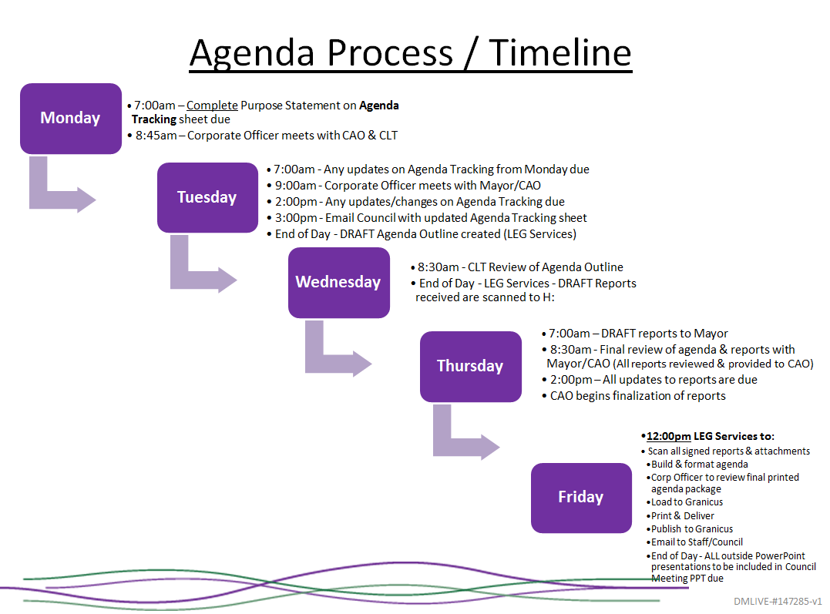

Appendix G: The ABCs of Other Comparable Communities

District of Squamish
The Procedure bylaw includes material on Committee of the Whole, Standing Committees and Select Committees.
  - Committee of the Whole
    - Contained in Procedure bylaw. Found no terms of reference (ToR) or any other form of documented guidance for its function
    - Standing Committees
      - Board of Variance
        - Meets the third Wednesday of the month as required.
        - Mandate: The Board of Variance considers appeals for minor variance to the Zoning Bylaw and rules on appeal applications as set out in Section 899 of the Local Government Act
        - Membership 3 people appointed by Council
        - TOR not listed
      - Community Development Standing Committee
        - Meets once a month
        - Mandate: To discuss, review and make recommendations to Council on policies and on significant strategic and operational activities relating to all aspects of Community Development
        - Specific TOR not listed
      - Digital Strategy Select Committee
        - Meets monthly
        - Mandate: To guide and advise the District in the development of a digital strategy; intended to engage the community in creating open dialogue, strategies and action on development of a digital strategy
        - A Councillor member chair
        - Membership is 14 people 2 of which are Councillors; others are representative of local organization or groups
      - Finance and Audit Standing Committee
        - Meets monthly
        - Mandate: To discuss, review and make recommendations to Council on policies and on significant strategic and operational activities relating to all aspects of financial services and finance related policies, financial planning, and annual reporting
        - Chair: Councillor
        - Membership: Entire Council
        - TOR set out on 2015 on a spreadsheet.
      - Public and Corporate Services Standing Committee
        - Meets monthly
        - Mandate: To discuss, review and make recommendations to Council on policies and on significant strategic and operational activities relating to all aspects of Governance and General Policies not considered in the other standing committees' mandate and on all aspects of services provided to the public
        - All of Council attend
        - No TOR listed
    - Select Committees
      - Housing Task Force (May be inactive)
        - Meets Monthly
        - Mandate: To provide direction for an improved and expanded inventory and available supply of Affordable Housing in a strategic and timely manner
        - Councillor is chair
        - 2 Councillors and 6 to 8 Members are appointed from community and represent groups or organizations
      - Official Community Plan Staff Advisory Steering Committee
        - Regular meetings of the Committee will be held as agreed to by the Committee, once established
        - The OCP Staff Advisory Steering Committee shall advise District staff and in particular:
          - Consider and evaluate issues referred to it by Council and report back to and make recommendations to Council on those issues
          - Advise District Staff on the preparation of a new Official Community Plan
          - Advise District Staff on the type and nature of public engagement employed during the OCP review process, including selection of any public engagement consultants; have a primary focus on guiding policy development in the new OCP document but not be restricted from examining other matters related to the new OCP document; assist and advise District Staff on the processing of public engagement input materials to ensure it accurately reflects the input provided; be a communication resource to the community on issues, events and activities associated with the OCP process, as required
        - Members: The Committee shall be composed of the Mayor, one (1) member of Council, and ten (10) additional members who shall be members of the public appointed by the C.A.O. on the basis of applications received by the District; one (1) additional member of the Committee shall be appointed from the Squamish First Nation
        - TOR in place
      - Public Art Select Committee
        - Meets monthly
        - Mandate: To provide oversight of the Public Art Policy, including the development of the Public Art Priorities
        - Mayor chairs; has 15 members
      - Smoke Bluffs Park Select Committee
        - meets in March, May and September
        - Mandate: The Smoke Bluffs Committee was established in 2007 to assist with the development and management of Smoke Bluffs Park
        - 12-person committee including one Council representative
    - ABC set up under Provincial Legislation
  - Library Board
        - Monthly except July, August and December.
        - The Squamish Public Library Board determines and adopts policies governing the services and operation of the library
        - One council rep on 8-person board

White Rock
  - The Procedure bylaw includes material on Committee of the Whole, Standing Committees and Select Committees; describes the duties of Standing and Select Committees; Council approves all TOR’s of committees
    - Committee of the Whole
      - Contained in Procedure bylaw; found no TOR or any other form of documented guidance for its function
      - Acting Mayor is chair
  - Standing Committees
    - Finance and Audit Committee
        - Chair is Councillor appointed by Mayor, all Councillors are members
        - Mandate: The Finance & Audit Committee (the “Committee”) assists City Council (“Council”) in fulfilling its oversight responsibilities relating to finance & audit matters delegated to management by Council; in particular, Committee assists Council by reviewing:
          - Key financial information that will be provided to the province or made public;
          - Strategic financial plans, operating, utilities and capital budgets;
          - External and internal audit activities;
          - The system of internal controls, risk management and financial information technology;
          - Investment management activities; and
          - Insurance coverage of significant risks and uncertainties
        - Meets 4 times a year
    - Grants‐In‐Aid Subcommittee
        - Three members of Council appointed by Mayor
        - The Grants-in-Aid Committee shall be responsible for reviewing grant applications received and shall prepare a recommended list of grant recipients and the suggested grant for each; list shall be presented to City Council for review and approval no later than April 15
    - Governance and Legislation
        - The Governance and Legislation Committee, a Standing Committee, (“Committee”) assists City Council (“Council”) in fulfilling its responsibilities relating to the legislation and governance practices in regard to operations of the City of White Rock (“City”). Responsibilities include the developing and reviewing of:
            - City Council Governance practices;
            - Human Resource policies; and
            - Council policies
        - Committee Chaired by Councillor
        - Membership: All Members of Council
      - External Communications Review Subcommittee
        - Chair is Councillor; members are 2 other Councillors
        - TOR not located
    - Land Use and Planning Committee
        - Responsible for reviewing matters related to the physical change and growth of the City such as the Official Community Plan, zoning, development permits and other land use issues and making recommendations to Council
        - Chair Acting Mayor; All Members of Council
        - TOR not located
    - Month of August Contract Committee
        - In accordance with Finance Policy No. 301 - Procurement and the City directive 107 - Procurement of Goods and Services, annually during the month of August when Council is in recess, contracts greater than $250,000 may be awarded by a committee of Council
        - Chair Acting Mayor; 3 other Councillors are members
    - Select Committees And Task Forces
      - All Abilities/All Ages Playground Committee
        - A Centennial Park all Abilities Playground Committee (“the Committee”) will be appointed to oversee the Playground project
          - The Committee will be comprised of representatives of the following organizations: 3 voting members of Council. Appointments will be made by City Council for the duration of the project which is expected to be completed by mid-2018. City staff will attend Committee meetings, as non‐ voting members, as required.
          - Peace Arch Hospital and Community Health Foundation (PAHF) ‐ 3 voting members of the PAHE Board or 2 voting members of the PAHF Board and 1 member of the South Surrey/White Rock Healthy Community Steering Committee. Appointments will be made by the PAHE Board for the duration of the project which is expected to be completed by mid-2018. In addition, the Executive Director of PAHF and the Community Engagement Coordinator will be non‐voting members of the Committee.
        - TOR approved
      - Cultural Advisory Committee
        - Composition: Up to thirteen (13) voting members appointed by City Council from the community at large, one (1) non‐voting member of Council, and City staff as required.
        - Term: The committee appointments will be made by City Council for a two (2) year term, with the initial appointments expiring December 31, 2018
        - The Cultural Advisory Committee will collaborate with stakeholders in the community with a view to implement the strategic plan to make the arts a mainstay of the City’s economic base and advance arts and culture in White Rock; Cultural Advisory Committee is to implement the actions identified in the 2014 ‐ 2018 Cultural Strategic Plan
        - TOR present
    - Economic Investment Committee
        - The Economic Investment Committee is a select committee of Council. The purpose of the Economic Investment Committee is to advise City Council and staff regarding matters referred to the Committee by Council regarding economic investment in the City.
        - Per website; Membership will consist of seven voting members appointed by Council from the community's development, business and planning sectors, one member of Council and the Chief Administrative. This differs from ToR which states up to thirteen (13) voting members appointed by Council representing a broad range of perspectives and expertise from the community’s business, investment, marketing, development and planning sectors.
        - Economic Investment Committee appointments are effective for a two (2) year term ending December 31, 2018.
    - Environmental Advisory Committee
        - The purpose of the Environmental Advisory Committee is to advise City Council and staff on environmental matters referred to the Committee by Council.
        - Composition: Up to seven (7) voting members appointed by Council from the community at large. One (1) member of Council non‐ voting and City staff as required.
        - Term: Environmental Advisory Committee appointments are effective for two (2) year term ending December 31, 2018.
    - Outstanding Canadians on the Peninsula
        - White Rock Outstanding Canadians on the Peninsula Legacy Program is the primary program for recognizing the contributions of citizens in making White Rock a successful, vibrant and harmonious community
        - Composition: One (1) resident, One (1) representative from the White Rock Museum and Archives, and One (1) member of Council ‐ non‐voting. No terms mentioned in policy
        - Acts under a policy
    - Public Art Advisory Committee
      - The mandate of the Public Art Advisory Committee (PAAC) will be to advise Council on the implementation of public art policies and projects for the City of White Rock.
      - Up to seven (7) voting members appointed by City Council from the community at large, one (1) non‐ voting member of Council
      - The committee appointments will be made by City Council for a two (2) year term
      - TOR established
    - Tour de White Rock
      - The Tour de White Rock Committee is mandated by City Council to organize, promote, and host a high profile elite caliber cycling event called the Tour de White Rock; Committee will act on behalf of the municipality to ensure the cycling event is a success through revenue generation, acquiring corporate sponsorship, developing business community relations, event marketing and arranging race day activities and entertainment. The Committee will govern the event and be responsible for developing operating principles.
      - Composition: Up to nine (9) voting members appointed by Council from the community at large, 1 member from the community with expertise in planning and organizing cycling races, 1 non‐voting member of Council and City staff as required (non‐voting). The Board positions are as follows: Chairperson, Vice Chairperson, Race Director, Treasurer, Secretary, Sponsorship, Community Events, Marketing and Communications and Business Liaison.
      - The Board appointments will be made by City Council for two (2) year terms expiring December 31, 2018.
      - TOR established
  - White Rock Sea Festival Committee
    - Purpose: The White Rock Sea Festival Committee (the Committee) is mandated by City Council to organize, promote, and host a high profile elite caliber summer festival called the White Rock Sea Festival. The Committee will have the authority to act on behalf of the municipality to ensure the festival is a success through revenue generation, acquiring corporate sponsorship, developing business community relations, event marketing and arranging festival activities and entertainment. The Committee will govern the event and be responsible for developing operating principles.
    - Composition: Up to nine (9) voting members appointed by Council from the community at large, plus one 1 non‐voting member of Council and City staff as required (non‐voting), and one (1) non‐voting representative of Semiahmoo First Nation (SFN).
    - The Committee appointments will be made by the City Council on an annual basis, expiring December 31 of each year.
    - TOR established
- External Organizations
    - Councillors are appointed to numerous external organizations; this included the Library Board

Cranbrook
- The Procedure bylaw includes material on Committee of the Whole, Standing Committees and Select Committees. The procedure Bylaw describes the duties of Standing and Select Committees; Council Approves all ToR’s of committees
- Committee of the Whole
  - Established within Procedure Bylaw
- Advisory Planning Commission
  - Purpose: make recommendations and advice Council om matters in Part 7 of the bylaw
  - Composition: 7 members residents, 2 non-voting members of Council
  - Term: residents not more than 3 years, Council reps are annual
  - TOR established
- Board of Variance
  - Purpose: Any Application to the Board shall be limited to matters specified in section 901 and 902 of the Local Government Act to be within the Board's jurisdiction
  - Composition: 3 people accordance to Act
  - Term: 3 years
  - Operates under a Bylaw
- Cranbrook in Motion Committee
  - The Cranbrook in Motion Committee is a select committee of Council established under section 142 of the Community Charter; formed to examine transportation planning and policy issues facing the City; a significant relationship between transportation, land use, social needs, traffic safety, parking and the environment; Committee will examine these connections, in the context of both short term and long term planning, and provide recommendations to City Council for all modes of local mobility
  - Composition: Committee shall consist of eight (8) voting members including two members from City Council
  - Term: Members representing the public-at-large shall be appointed by Council for a term of up to three years and for no more than two terms; members representing an agency or organization shall be appointed by Council for one year, renewable at Council’s discretion upon written confirmation by the agency or organization of the member’s status of employment with the agency/organization and the agency/organization recommendation to appoint the representative
- Cranbrook Public Library Board
  - The terms of Reference for the Library Board, as set out in accordance with the Library Act, are attached as Schedule "A" to form part of Library bylaw.
  - Board made up of 9 members appointed by Council which includes 1 member of Council.
- Urban Deer Management Advisory Committee
  - Purpose: The Urban Deer Management Advisory Committee is a select committee of Council established under section 142 of the Community Charter; formed to examine the issues related to urban deer within the boundaries of the City and development of an ongoing management plan
  - Membership: The Committee shall consist of eight (8) voting members as follows:
    - Two members from City of Cranbrook Council
    - One representative from the Ministry of Environment (MOE)
    - Five members from citizens selected “at large” to provide balance in the committee
  - Term: Members shall be appointed by Council for a term of up to three years
  - TOR established
- Heritage Committee
  - Purpose: The Heritage Committee is a select committee of Council established under section 142 of the Community Charter; formed to provide advice to City Council on matters relating to heritage, and to review and make recommendations regarding the nominations for the Heritage Register
  - Membership: The Committee shall consist of four (4) voting members as follows:
    - One City of Cranbrook Council member
    - Designated heritage member from a recognized heritage group such as Cranbrook Archives Museum and Landmark Foundation (CAMAL).
    - Two members from citizens selected “at large” based on their knowledge or interest in heritage.
  - Term: Members representing the public-at-large shall be appointed by Council for a term of up to three years and for no more than two terms. Members representing an agency or organization shall be appointed by Council for two-year term, renewable at Council’s discretion upon written confirmation by the agency or organization of the member’s status of employment with the agency/organization and the agency/organization recommendation to appoint the representative.
- Key City Theatre Society
  - While this organization appears on the City website as a “Committee” it is constituted as a Society under the Society Act.
  - Members join the Society. Members elect directors at AGM

Fort St. John
- The Procedure bylaw includes material on Committee of the Whole, Standing Committees and Select Committees; describes the duties of Standing and Select Committees.
- Standing committees must consider, inquire into, report and make recommendations to Council about all of the following matters:
      - matters that are related to the general subject indicated by the name of the committee;
      - matters that are assigned by Council;
      - matters that are assigned by the Mayor
  - Select committees must consider, inquire into, report and make recommendations to Council about the matters referred to the committee by Council
- Healthy Living Alliance
  - Mission Statement: The Fort St. John Healthy Living Alliance is an inclusive, collaborative and energetic network of organizations that are dedicated to proactively educating and increasing capacity in the community to promote healthy living
  - Co-Chaired by the City of Fort St. John and Northern Health since 2005, the Alliance membership includes, but is not limited to, health organizations, health care professionals, social service organizations, non-profit organizations, advocacy groups, local government, educators, employers, and multi-cultural groups
- Youth Advisory Council
  - The Fort St. John Youth Advisory Council will enhance the quality of life of youth by providing information, resources, and leadership to both their peers and City Council, while creating positive alternative activities for young people to participate in
- Various Standing other committees of Council:
  - Emergency Planning Committee
  - City of Fort St. John - BC Hydro Joint Planning Committee for Site C
  - Energy Literacy Committee
  - Parcel Tax Review Committee
  - Peace Valley OSB Community Advisory Committee
  - Affordable Housing Committee
  - Community Awards
  - Welcoming Community Committee
- Other Committees
  - North East BC Resource Municipalities Coalition
  - BC Hydro Peace Williston Advisory Committee
  - Resource Works Advisory Committee
  - Community Bridge (North Peace Community Resources Society)
  - National Zero Waste Council - Food Working Group
  - BC Hydro Peace Region Non-Profit Community Fund Committee

West Kelowna
- Procedure bylaw states:
  - Committee of the Whole: meetings will be scheduled on an ‘as required’ basis
  - The Acting Mayor shall act as Chairperson of the Committee of the Whole, unless otherwise determined by the Mayor
  - The Council, pursuant to the Council Delegation of Powers Bylaw has delegated its authority to the Committee of the Whole to exercise any of the executive and administrative powers of Council
    - The Committee of the Whole may, by a majority vote of the Committee, refer any item appearing on the agenda to the regular Council for its consideration. If an item is referred in the manner noted above, the Corporate Officer shall place the item referred on the next regular Council agenda.
  - Duties of Commissions/Committees and Advisory Bodies
    - Commissions/Committees and Advisory Bodies must consider, inquire into, report, and make recommendations to Council about all of the following matters: matters that are related to the general subject indicated by the name of the Commission; matters that are assigned by Council or the Mayor.
- Advisory Committee on Health Care
  - The purpose of the Advisory Committee on Health Care is to promote open communication and an active working partnership between the District of West Kelowna Council (DWK), Interior Health (IH), and residents to provide residents with the highest possible quality of health care
  - Appointments to the Committee shall be by resolution of Council.
  - The Committee shall consist of seven (7) members with five (5) regular voting members who will be recruited from the West Kelowna Community at large
- The five regular Committee members at large will be appointed for a three-year term; reappointment to the Committee will be at the discretion of Council Advisory Planning Commission
  - TOR established
- The Advisory Planning Commission (APC)
  - Purpose: APC has been established to provide information and feedback to City of West Kelowna Council and staff on issues concerning the public and the municipality related to land use and community planning; role of the Commission is to advise Council on matters respecting land use, community planning, or proposed bylaws and certain permits under Divisions 2, 7, and 9 of Part 26 of the Local Government Act, and for this purpose, Council may refer matters to the Commission by resolution or bylaw
  - Membership: The Commission shall be comprised of five (5) to seven (7) regular members and two (2) alternate members, appointed by Council resolution.
- Agricultural Advisory Committee
  - Purpose: The Agricultural Advisory Committee (AAC) has been established to assist City of West Kelowna staff and Council in protecting, enhancing and promoting agriculture within the municipality; AAC is being established to assist staff and Council in protecting, enhancing and promoting agriculture within the City ; role is to advise the Council on land use and economic development matters with respect to agriculture, and to act as a liaison between Council and the agri-business community
  - Membership: The AAC shall consist of 5 to 7 voting members appointed by the City Council from the agricultural community at large; two (2) City staff to act in a non-voting liaison capacity, and optional non-voting members to act in a resource/liaison capacity
  - TOR established
- Board of Variance:
  - The Board of Variance deals with applications for minor variances in situations where compliance with the Zoning Bylaw regarding siting, dimensions or size of a building or structure, siting of a manufactured home, etc. would cause a person undue hardship
  - The board is made up of five members who serve a three-year term, from 2015 to 2017 inclusive, 2017 to 2019 inclusive
  - Established pursuant to Act
- Economic Development Committee
  - Purpose: The Economic Development Committee was established to provide advice and support on local and national economic trends as well as participate in annual economic development planning activities
  - Membership: 7 members from business community
      - Appointed members will serve for a minimum two-year term
  - TOR established

Port Moody
- Procedure Bylaw includes procedures for Committee of the Whole, and duties and procedures for standing committees and select committees
  - The Municipality has also passed a Corporate Policy for Committees called “Council Committee System Policy”; covers standing committees, select committees, statutory committees and task forces; policy covers a range of items from appointment to agenda, etc.
  - Committee T0R refer to this committee policy for operation details
- Committee of the Whole
  - All members of Council
- Police Board
  - Statutory committee
- Finance Committee
  - All of Council as members
  - Role cannot be found, other than responsible for area consistent with title
- Climate Action Committee
  - To provide Council with advice and recommendations on ways in which the City can achieve carbon neutrality, specifically through the reduction of Greenhouse Gas (GHG) emissions as detailed below and within the terms of the Council Committee System Policy and the Council Strategic Plan
  - In addition to the two (2) Council representatives from the Environmental Protection Committee serving as Chair and Vice-Chair, the Committee will comprise the following a number or entities
  - Meet monthly
- Advisory Design Panel:
  - Mandate: The role of the Advisory Design Panel is to advise the General Manager of Development Services and/or City Council on the quality of design of development projects under review by the City
  - The Panel will be comprised of nine members:
  - Two-year appointment
- Arts and Culture Committee
  - Provides Council with advice and recommendations on matters related to arts and culture within the terms of the Council Committee bylaws policy.
  - In addition to the two (2) Council representatives serving as Chair and Vice-Chair, the Committee will comprise representatives from the Boards of Directors of a number of organizations and the public at large
  - 2-year terms
- Board of Variance
  - Mandate: The Board is an avenue for appeal of the interpretation and the strict application of certain local government provisions and regulations in specific circumstances defined in the legislation; functions separately from the local government that established it; own authority under the Community Charter
  - The Board of Variance (the “Board”), established by previous bylaws of the City is continued and shall consist of five (5) members appointed by Council
  - 3-year terms
- City / CPR Community Advisory Panel
  - Provides a forum for the exchange of information between the City of Port Moody and Canadian Pacific Railway
  - 2-year appointment
  - T0R established
- Community Planning Advisory Committee
  - Mandate: Provides Council with advice and recommendations on proposed land use changes and related matters
  - The Committee will comprise the following members to be appointed by Council:
    - One (1) member of Council to serve as Chair;
    - One (1) member of Council to serve as Vice-Chair;
    - Five (5) remaining members of Council;
    - Other members representing neighbourhood associations as listed
  - 2-year terms
  - T0R established
- Economic Development Committee
  - Mandate: To provide Council with advice and recommendations on strategic economic development directions and related matters within the terms of the Council Committee System Policy and the Council Strategic Plan; serve a liaison function for community organizations that are engaged in the development and delivery of programs and initiatives intended to promote and enhance business development
  - In addition to the two (2) Council representatives serving as Chair and Vice-Chair, the Committee will comprise the following:
      - Six (6) members made up of representatives from community areas identified as follows:
      - Four (4) members from the community at large; and
      - One (1) member appointed by the Chamber of Commerce (non-voting member)
  - 2-year term
  - TOR established
- Environmental Protection Committee
  - Mandate: To provide Council with advice and recommendations on environmental issues as detailed below and within the terms of the Council Committee System Policy and the Council Strategic Plan
  - In addition to the two (2) Council representatives serving as Chair and Vice-Chair, the Committee will comprise the following:
    - Six (6) members made up of representatives from community areas identified
    - Five (5) members from the community at large
  - 2-year term
  - TOR established
- Heritage Commission
  - The Commission shall act as an advisory body to Council on matters relating to Port Moody's natural and cultural heritage resources, including heritage buildings, sites, and neighbourhoods
  - The Commission shall be composed of a minimum (10) members appointed by Council as follows:
    - Two (2) members of Council who shall be the Chair and Vice-Chair;
    - A minimum of seven (7) members from the City at large who shall be residents of the City and who may have knowledge of local history, local architecture, landscape architecture, or building conservation and restoration; and
    - One (1) member recommended by the Port Moody Heritage Society from its membership.
  - 2-year terms
  - T0R established
- The Library Board
  - The public library board is a governance board which operates under the authority of the Library Act of British Columbia; board is responsible for providing library services and programs in Port Moody; trustees establish the policies, goals and objectives of the library and advocate for the library in the greater community; day-to-day operation of the library is the responsibility of the library director and senior staff
  - The library board is made up of nine Port Moody residents appointed by Port Moody City Council; eight trustees are members of the general public, appointed for two-year terms (to a maximum of four terms); one Port Moody city Councillor is appointed annually; library director serves as ex-officio secretary to the board
- Parks and Recreation Commission
  - The Commission shall act as an advisory body to Council regarding the public use and needs of amenities, facilities, programs, and services provided by the Parks Division and Recreation Division
  - The Commission shall be composed of a minimum of eleven (11) members appointed by Council as follows:
    - Two (2) members of Council who shall be the Chair and Vice-Chair;
    - A minimum of seven (7) members from the City at large who shall be residents of the City of Port Moody;
    - One (1) representative from the Youth Focus Committee; and
    - One (1) representative from the Seniors Focus Committee.
  - 2-year terms
  - T0R established
- Seniors Focus Committee
  - To provide Council with advice and recommendations on seniors’ issues, strategies, and initiatives as detailed below and within the terms of the Council Committee System Policy and the Council Strategic Plan
  - In addition to the two (2) Council representatives serving as Chair and Vice-Chair, the Committee will comprise the following:
    - Ten (10) members at large – residents aged 55 years or older; and
    - One (1) representative from the Seniors Friendship Society.
  - 2-year terms
  - T0R established
- Tourism Committee
  - To provide Council with advice and recommendations on strategic tourism initiatives and related matters as detailed below and within the terms of the Council Committee System Policy and the Council Strategic Plan
  - In addition to the two (2) Council representatives serving as Chair and Vice-Chair, the Committee will comprise the following:
    - Three (3) members representing the community at large; and
    - Three (3) business operators.
  - 2-year term
  - TOR established
- The Youth Focus Committee
  - To provide Council with advice and recommendations on youth issues, strategies, and initiatives as detailed below and within the terms of the Council Committee System Policy and the Council Strategic Plan
  - In addition to the non-voting Council representative and alternate Council representative, the Committee will comprise the following:
    - Up to 15 community youth members (defined as any person between the ages of 12 and 19).
  - 2-year term
  - TOR established

Mission
- Procedure Bylaw established process for the Committee of the Whole, standing committees, and select committees.
  - Mission has a committee policy called “Protocol for Council Committees”; does not appear on the website
- Cultural Resources Commission
  - The Cultural Resources Commission provides the expertise of a diverse group of people to make recommendations that will shape the infrastructure and support base for regional cultural activities, services and organizations; recommendations will sustain and enhance the social and economic benefits of culture which includes arts, multiculturalism throughout the District
  - There will be a total of 10 -12 voting members, who are knowledgeable about the community and reflect broad interests drawn from a number of disciplines
  - 2-year term
  - TOR established
- Joint Shared Services Committee (JSSC)
    - Mandate: provide governance and make decisions regarding the JWS and JSS in accordance with the Water & Sewer Commission Establishment and Delegation Bylaw, 2005 (Bylaw No. 1488-2005); perform duties as outlined in the Abbotsford Mission Water and Sewer Services Agreements; assist and make recommendations to Abbotsford and Mission Councils, regarding the Central Fraser Valley Transit System, including changes, fares, improvements, efficiencies, long term funding and governance; and advise, assist and make recommendations to Abbotsford and Mission Councils regarding the operation of the AMRD, including recycling operations, programs and funding
  - The Joint Shared Services Committee will be composed of up to six (6) voting members appointed by each Council:
    - three (3) members of the City of Abbotsford Council; and
    - three (3) members of the District of Mission Council.
  - TOR established and available on Abbotsford website.
- Mission Community Heritage Commission
    - The Mission Community Heritage Commission will advise Council on progress toward implementation of the Heritage Strategic Plan adopted in 2006 and on those items referred by Council; appoint sub-committees; explore proposals for addressing actions outlined in the Mission Heritage Strategic Plan; annually report to Council on its activities in the form of a work plan; and issue a progress report on the previous year’s work plan
  - There will be a minimum of 5 and a maximum of 11 voting members, who may include representatives from various professions and associations
  - 2-year term
  - TOR established
- Mission Traffic and Transit Committee
  - The mandate of the Mission Traffic and Transit Committee (MTTC) is to oversee traffic safety and transit within Mission; the MTTC is established to engage the community to receive its concerns and suggestions and to make recommendations regarding all traffic safety and transit issues including those related to the Central Fraser Valley Transit System and the West Coast Express; from time to time, recommendations are also made to maximize efficiency with regional transit systems such as the Translink system in Metro Vancouver and the Chilliwack Transit System
  - Membership:
    - Voting Members (11 total)
      - The Chairperson shall be appointed by Council for the duration of that Council’s term;
      - The Vice-Chairperson shall be appointed by Council for the duration of that Council’s term;
      - One person appointed by Mission Community Services;
      - One person appointed by Mission Public Schools;
      - One person appointed by Mission Association for Community Living;
      - One person appointed by Mission Youth Committee;
      - One person appointed by Mission Association for Seniors Housing;
      - One person appointed by Mission Seniors Activity Centre;
      - One person appointed by the United Way Fraser Valley; and
      - Two members at large from the general public
    - Non-voting Members
      - The Director of Engineering and Public Works or their delegate;
      - The Director of Development Services or their delegate;
      - An administrative staff person who will alternate from Engineering and Public Works and Development Services on an annual basis;
      - The Manager of Social Development;
      - BC Transit staff (as required); • Bus contracting company staff (as required); and
      - RCMP member (as required)
  - TOR established
- Parks and Recreation Advisory Committee
  - The Parks and Recreation Advisory Committee is established by the District of Mission Council and supports the District’s mission statement: “Our purpose is to build a safe, healthy and inclusive community that is abundant in the economic, cultural and recreational opportunities”; provides the expertise of a diverse group of people to make recommendations that will shape the infrastructure and support base for the District of Mission’s parks, trails, recreational activities, services and organizations
  - 10 members on committee
  - TOR not listed.

Appendix H Template Governance & Priorities Agenda

- Call to Order
- Prior GPC & Council Minutes
- Adoption of Agenda
- Delegations
- Public Advisory Committees
- Parks, Infrastructure and Transportation
- Planning and Environmental Services
- Finance, Audit and Corporate Services
- Community, Cultural Services and Engagement
- Key Councillor initiatives/strategic priorities
- Public Participation and Comment (Roundtable)
- Other

